|  |  |  |
| --- | --- | --- |
|  | ISSN: 3056-9680 (Online)  **Journal of Public and Private Issues: JPPI**  Journal homepage: https://so17.tci-thaijo.org/index.php/jppi  E-mail: jppissues@gmail.com |  |

**Developing Strategic guidelines to improve English language skills of vocational students in Linhai Taiyun vocational school, China**

**Wu Weiyi1, Nipaporn Khamcharoen2, Ntapat Worapongpat3 \***

1,2,3 Dhonburi Rajabhat University

Email: dr.thiwat@gmail.com3*

|  |  |  |
| --- | --- | --- |
| ARTICLE INFO |  | ABSTRACT |
| Article history:  Received: August 6, 2024  Revised: August 21, 2024  Accepted: August 29, 2024 |  | This Article aimed to study 1) to explore the problems and needs to improve the English language skills of vocational school students, and 2) to develop guidelines for managing the English language skills of vocational school students. The sample was 117 teachers and 267 students. The instrument for collecting data was a five-point Likert rating scale used to assess respondents’ problems and needs in education management--analysis data by descriptive statistics and content analysis. The research results were found as follows:  1) The problems and needs to improve the English language skills of vocational students were at the "highest" level; 2) The guiding ideology of improving the English language skills of vocational students includes: improving their English language skills. This study will propose targeted and practical strategies and methods by comprehensively analyzing the challenges and needs currently faced by students in this school, combined with the latest language education theories and practices. These guidelines are intended to help students overcome language barriers, improve their English listening, speaking, reading, and writing skills, enhance their communication skills, and ultimately enhance their professional competitiveness and employment opportunities. |
| Keyword:  English language skill  strategic guideline  vocational school  vocational students |  |

# **Introduction**

In today's rapidly developing world of globalization and information, English, as the main tool for international communication, increasingly demands higher English skills from vocational school students. However, many vocational school students face challenges in English learning, showing a lack of interest and motivation. Improving the English skills of vocational school students involves their future career development and relates to the country's international competitiveness and the overall quality of education in society. According to data from the education department, the majority of vocational school students have not achieved ideal levels of English academic performance and practical abilities. For example, a recent survey of vocational school students in China showed that over 60% of students have significant deficiencies in their English listening and speaking abilities, which limits their career choices and international communication skills (Wang, B. 2024, pp157-159). Previous research has focused mainly on improving classroom teaching methods and learning resources. However, despite the results of these efforts, there is still a gap between research and practice in improving vocational school students' English language skills. Future research can explore more personalized and diversified English education strategies to better meet the learning needs and career development requirements of vocational school students. For example, firstly, establish a "help and release" English classroom for higher vocational education, fostering student exploration and self-confidence through guided autonomy; secondly, cultivate students' humanistic qualities to facilitate easier foreign language acquisition by expanding cultural understanding; thirdly, integrate professional disciplines with foreign language learning to enhance comprehensive abilities and self-confidence; finally, create a supportive foreign language learning community to foster interactive learning and cooperative progress among students (Cui H, 2024). Therefore, this study aims to fill the gap between existing research and practice, explore new English education models and strategies, effectively improve vocational school students' English skills, and promote their development and success in their career and international competition.

This research field focuses on improving the English language skills of vocational school students, which involves a key educational area of how to effectively enhance the English proficiency of non-English major students. Vocational school students typically have specific learning needs and backgrounds, and their future careers require basic English communication skills. However, limited by school resources and individual differences among students, English education faces diverse and personalized challenges. In this field, many researchers have explored different teaching methods and educational strategies to improve the English skills of vocational school students. For example, Teacher Cui, N. (2023) studied the application effect of using multimedia and interactive teaching tools in vocational school English education. Cui, H. (2024) explored the impact of project-based learning and interdisciplinary education on students' English proficiency. These studies provide valuable insights and practical experience for understanding how to effectively promote English learning among vocational school students. The main target audience of this study includes vocational school teachers and students. Vocational school teachers can apply research findings in teaching practice to improve their teaching methods; students can identify learning difficulties and get help from teachers to improve their English skills effectively and efficiently. Conclude the research problems

What are the primary challenges and needs faced by vocational school students in improving their English language skills, and how do these issues impact their career prospects and international communication abilities? How effective are current English language teaching methods and resources in addressing these challenges, and what gaps exist between research findings and practical outcomes in vocational school settings? What new and targeted educational strategies and models can be developed to enhance English proficiency among vocational school students, taking into account their specific learning needs, career development goals, and the limitations of existing resources?

These research problems aim to identify the key issues in English language education for vocational students, evaluate the effectiveness of current methods, and propose innovative strategies to bridge the gap between research and practice. This study focuses on Linhai Taiyun Vocational School students, representing the student population in relatively underdeveloped regions of China's regional economy. The school has relatively scarce learning resources, and there are significant differences in students' learning motivation and background.

**Objectives**

1. To investigate the problems and needs of English language skills of vocational students in Linhai Taiyun Vocational School.

2. To propose guidelines to improve the English language skills of vocational students in Linhai Taiyun Vocational School.

**Literature review**

Wan, M. (2024, pp. 81-83). The development of economic globalization requires talents majoring in English. English has always occupied a high status in the world, and more and more people are aware of the importance of English. The education of English majors in my country has always been a key issue of social concern.

Yang, B. (2024, pp. 20-23). with the continuous deepening of education reform, the digital transformation of college English education has received more and more attention. To solve the structural problems of college English teaching and learning under the background of informatization and smart education, and to provide students with diversified and personalized educational resources and learning models, the construction of ubiquitous learning has become a necessary way and effective means.

Cui, N. (2023, pp. 112-115). With the continuous development of new media technology, teachers should scientifically use new media to build efficient English classes in higher vocational English teaching classes and optimize teaching based on students’ actual learning practices and specific teaching content to ensure Classroom teaching efficiency, cultivate students' professional abilities, comprehensively improve English teaching level, increase students' enthusiasm to participate in class, and help students improve their comprehensive English ability.

Yu, T. (2023, pp. 91-96). In view of the strategic need for business English international talents in the Guangdong-Hong Kong-Macao Greater Bay Area under the background of the construction of international education demonstration zones, taking the construction of the national vocational education "Double High Plan" as an opportunity, from the perspective of international talent training Starting from the comprehensive international talent connotation and industry international talent needs, based on the "English Curriculum Standards for Higher Vocational Education" and referring to the ability requirements for foreign-related communication and multicultural exchanges in the workplace in the "English Curriculum Standards", from the perspective of cognition, emotion Analyze the core competencies of higher vocational English from the three dimensions of behavior and behavior, and propose ways to improve the quality of higher vocational English education such as serving industry needs, cultivating international perspectives, building international platforms, and strengthening teacher allocation. English courses in higher vocational colleges should focus on cultivating international talents and adapting to the international development trend by improving the quality of education.

**Conceptual framework**

This research is a research study. To propose guidelines to improve the English language skills of vocational students in Linhai Taiyun Vocational School. The researcher defines the research conceptual framework based on the concept/theory to investigate the problems and needs of English language skills of vocational students in Linhai Taiyun Vocational School. The details are as figure 1

The problems of the English language skills of vocational students in Linhai Taiyun Vocational School.

Strategic guidelines to improve English language skills of vocational students in Linhai Taiyun Vocational School.

The needs of the English language skills of vocational students in Linhai Taiyun Vocational School.

Figure 1 Conceptual framework

**Methods**

In this chapter, there are 4 sections; namely, 1) Population and Samples 2) research instrument 3) data collection, and 4) data analysis.

**1. Population and Samples**

To further study and understand the current situation of English language skills improvement strategies in Linhai Taiyun Vocational School, especially the existing problems, the author selected the teachers, and students of Linhai Taiyun Vocational School for research. There are currently 166 teachers and 800 students. The samples of this study are 117 teachers and 267 students in Linhai Taiyun Vocational School. (Yamane, 1973)

**2. Research instrument**

The questionnaire has three parts: namely, 1) General information; 2) Problems with English language Skills Improvement; and 3) Needs for English language Skills Improvement. The questionnaire was established based on Linhai Taiyun Vocational School's English Language Skills Improvement Research Project guidelines and concepts. For this part, the three specialists evaluated the questionnaire for the Index of Congruence scores (IOC scores). Each question in the questionnaire evaluated with the range of I0C 0.66 to 1.00 was employed meeting for this research.

**3. Data Collection**

For this research project, the researcher herself collected the data and information from the sample groups. The sample groups were informed of the data collection purposes and made an appointment. The researcher submitted a letter of permission to the college director in advance to ask permission to collect the data and information from the sample group at Linhai Taiyun Vocational School.

**4. Data Analysis**

The Data and information collected were analyzed, interpreted, and then presented in terms of frequency, percentage, mean (C:\Users\11240\AppData\Local\Temp\ksohtml22132\wps1.png), and standard deviation (S.D.). The Five Point Likert Rating Scale was used to evaluate the respondents' problems and needs about English skills.

**Results**

Table 1 Problems of English language skills of vocational students in Linhai Taiyun Vocational School for students.

|  |  |  |  |
| --- | --- | --- | --- |
| Questions | N=360 | | Level of problems |
| C:\Users\lenovo\AppData\Local\Temp\ksohtml6956\wps1.png | S.D. |
| 1. The most critical grammatical mistakes students communicate in English include subject-verb agreement errors, misuse of articles, and incorrect word order. | 4.64 | 0.89 | Highest |
| 2. The major difficulties students encounter in English listening comprehension are understanding different accents, grasping fast speech, and identifying implied meanings. | 4.58 | 0.95 | Highest |
| 3. The most common mistakes students make in English oral expression are incorrect verb tense usage, pronunciation mistakes, and inadequate vocabulary. | 2.81 | 1.39 | Middle |
| 4. Common errors students make in English writing include punctuation errors, spelling mistakes, and problems with sentence structure and coherence. | 4.63 | 0.907 | Highest |
| 5. Students' motivation and interest in learning English vary. | 4.79 | 0.68 | Highest |
| 6. The biggest challenges students encounter in learning English are related to various grammatical rules, vocabulary, and pronunciation. | 2.92 | 1.36 | Middle |
| 7. Key areas for students to improve their English skills include oral fluency, listening comprehension, and writing accuracy. | 4.53 | 0.95 | Highest |
| 8. Students' feedback and expectations regarding English teaching often revolve around the desire for engaging and interactive lessons that focus on practical language use. | 4.65 | 0.88 | Highest |
| 9. Students use extracurricular English learning resources such as online courses, language exchange programs, and language learning apps to improve their learning. | 3.00 | 1.34 | Middle |
| 10. Teacher support and assistance are important for students in their English learning, including understanding complex grammatical rules, practicing speaking, and receiving feedback on writing. | 4.67 | 0.84 | Highest |
| 11. Students evaluate the interest and practicality of English teaching content based on its relevance to their daily lives and its ability to engage and motivate them. | 4.59 | 0.93 | Highest |
| 12. Students' receptiveness is different from various English teaching methods, while others prefer more interactive and immersive approaches. | 4.53 | 0.29 | Highest |
| 13. Students would like to receive help and guidance in English learning through personalized feedback, additional practice materials, and individualized learning plans. | 4.58 | 0.30 | Highest |
| 14. Students would like to improve their speaking, make writing fluency, and communicate more effectively. | 4.51 | 0.29 | Highest |
| 15. Students evaluate and expect their English learning outcomes based on their ability to communicate confidently, understand English media, and pass language proficiency exams. | 4.59 | 0.29 | Highest |
| 16. Students learning English require teachers to adjust their teaching methods, learning speed, and materials to suit individual learning styles and needs. | 4.75 | 0.73 | Highest |
| 17. Students improve autonomous learning abilities in English such as setting goals, managing time effectively, and finding additional self-study resources. | 3.30 | 1.24 | Middle |
| 18. Students emphasize English learning strategies including regular practice, seeking feedback, and using contextual clues to improve their English skills. | 4.71 | 0.76 | Highest |
| 19. Study habits that students reinforce in their English studies include developing a consistent study plan, seeking out challenging material, and actively participating in learning activities. | 4.58 | 0.93 | Highest |
| 20. The positive and appropriate learning environment for students includes creating a space conducive to learning, reducing distractions, and cultivating a supportive learning community. | 3.45 | 1.22 | Middle |
| Total | 4.26 | 0.97 | High |

According to Table 1, the total is 4.26 at high level. It can be seen from the table that question 5: Students' motivation and interest in learning English vary at the highest level (C:\Users\lenovo\AppData\Local\Temp\ksohtml6956\wps2.png = 4.79, S.D. = 0.68). Next is question 14: Students would like to improve their speaking, improve writing fluency, and communicate more effectively at the highest level (C:\Users\lenovo\AppData\Local\Temp\ksohtml6956\wps2.png = 4.76, S.D. = 0.74). Question 16: Students learning English require teachers to adjust their teaching methods, learning speed, and materials to suit individual learning styles and needs at the highest level ( C:\Users\lenovo\AppData\Local\Temp\ksohtml6956\wps2.png=4.75, S.D.=0.73). The study also showed that the majority of the 20 questions were rated as high-level or above.

Table 2 Needs of English language skills of vocational students in Linhai Taiyun Vocational School for students.

|  |  |  |  |
| --- | --- | --- | --- |
| Questions | N=60 | | Level of Needs |
| **C:\Users\lenovo\AppData\Local\Temp\ksohtml6956\wps3.png** | S.D. |
| 1. You need to improve your English grammar skills. | 4.80 | 0.62 | Highest |
| 2. You need to improve your English listening comprehension skills. | 4.50 | 1.03 | High |
| 3. You need to correct your grammatical mistakes in English oral expression. | 3.60 | 1.32 | High |
| 4. You need to correct your writing errors in English. | 4.56 | 0.93 | Highest |
| 5. You need to motivate yourself and engage in learning English. | 4.57 | 0.93 | Highest |
| 6. You need to overcome your challenges in learning English. | 4.62 | 0.89 | Highest |
| 7. You need to improve your English skills in key areas. | 2.99 | 1.19 | Middle |
| 8. You need to receive your feedback and expectations regarding English teaching. | 4.36 | 1.12 | High |
| 9. You need to use extracurricular English learning resources. | 4.65 | 0.83 | Highest |
| 10. You need support in key aspects of your English learning. | 4.61 | 0.87 | Highest |
| 11. You need to ensure the interest and practicality of English teaching content. | 3.06 | 1.37 | Middle |
| 12. You need to adapt to different English teaching methods. | 4.69 | 0.77 | Highest |
| 13. You need help and guidance in your English learning. | 4.74 | 0.64 | Highest |
| 14. You need to address your desire for improvement in English learning. | 3.76 | 1.32 | High |
| 15. You need to meet your expectations and evaluations of your English learning outcomes. | 3.90 | 1.17 | High |
| 16. You want teachers to adjust to meet your needs in English learning. | 4.50 | 0.99 | High |
| 17. You need to enhance your independent learning ability in English learning. | 4.64 | 0.86 | Highest |
| 18. You need to focus on specific learning strategies in English learning. | 3.50 | 1.24 | Middle |
| 19. You need to strengthen your learning habits in English learning. | 4.66 | 0.83 | Highest |
| 20. You need to improve the learning environment for yourself in English learning. | 4.60 | 0.89 | Highest |
| Total | 4.32 | 0.99 | High |

According to Table 2, the total is 4.32 at high level. question 1: You need to improve your English grammar skills at the highest level ( C:\Users\lenovo\AppData\Local\Temp\ksohtml6956\wps2.png=4.80, S.D.=0.622). Question 13: You need help and guidance in your English learning at the highest level ( C:\Users\lenovo\AppData\Local\Temp\ksohtml6956\wps2.png= 4.74, S.D.= 0.64). Question 1l2: You need to adapt to different English teaching methods at the highest level ( C:\Users\lenovo\AppData\Local\Temp\ksohtml6956\wps2.png= 4.69, S.D.= 0.77).

The Strategic guidelines to improve English language skills of vocational students in Linhai Taiyun Vocational School consist of:

Topic 1 Preamble

Topic 2 Course positioning and nature

Topic3 Teaching objectives and teaching requirements

Topic 4 Course settings

Topic 5 Evaluation and testing

Topic 6 Teaching methods and means

Topic 7 Teaching management

Topic 8 Supplementary Provisions

**Discussions**

According to Yang Bin (2024, pp. 20-23), with the continuous deepening of education reform, the digital transformation of college English education has received more and more attention. To solve the structural problems of college English teaching and learning under the background of informatization and smart education, and to provide students with diversified and personalized educational resources and learning models, the construction of ubiquitous learning has become a necessary way and effective means. On the one hand, the digital transformation of college English education should strive to build ubiquitous learning resources for college English that are practical, rich, open, integrated, orderly, and controllable; on the other hand, the success of the digital transformation of college English education also depends on whether a suitable ubiquitous learning resource has been established.

**Body of knowledge**

|  |  |  |  |  |  |
| --- | --- | --- | --- | --- | --- |
| Effective English Teaching Strategies | | | | | |
|  | Strategy | Process | | Purpose | |
| 1 | Personalized learning | Tailor content and strategies | | Based on learning styles, interests, abilities | |
| 2 | Technology-enhanced teaching | Online platforms, apps, multimedia | | Interactivity, feedback, personalized paths | |
| 3 | Balance of language input and output | Listening and reading vs. speaking and writing | | Develop comprehensive language skills | |
| 4 | Task-based teaching | Learn language through tasks (problem-solving, projects) | | Enhance practical communication skills | |
| 5 | Feedback and assessment | Timely feedback | | Diverse assessment methods (oral, writing, tests) | |
| 6 | Cultural awareness and intercultural communication | Foster cultural awareness | | Develop intercultural communication | |
| 7 | Teacher professional development | Continuous training | Reflective practice | | Enhance teaching skills and effectiveness |

According to a survey targeting both teachers and students, students need to receive support and assistance from teachers in English learning, including understanding complex grammar rules, practicing speaking, and obtaining writing feedback. You need help and guidance in your English learning. The two questions have the highest scores. The conclusion drawn from the analysis of the entire data is that students expect more help from teachers in the process of learning English.

Based on the survey results and group discussion, we have identified the following key points for improving English language skills management. Synthesize the overall finding as the mind Mapping

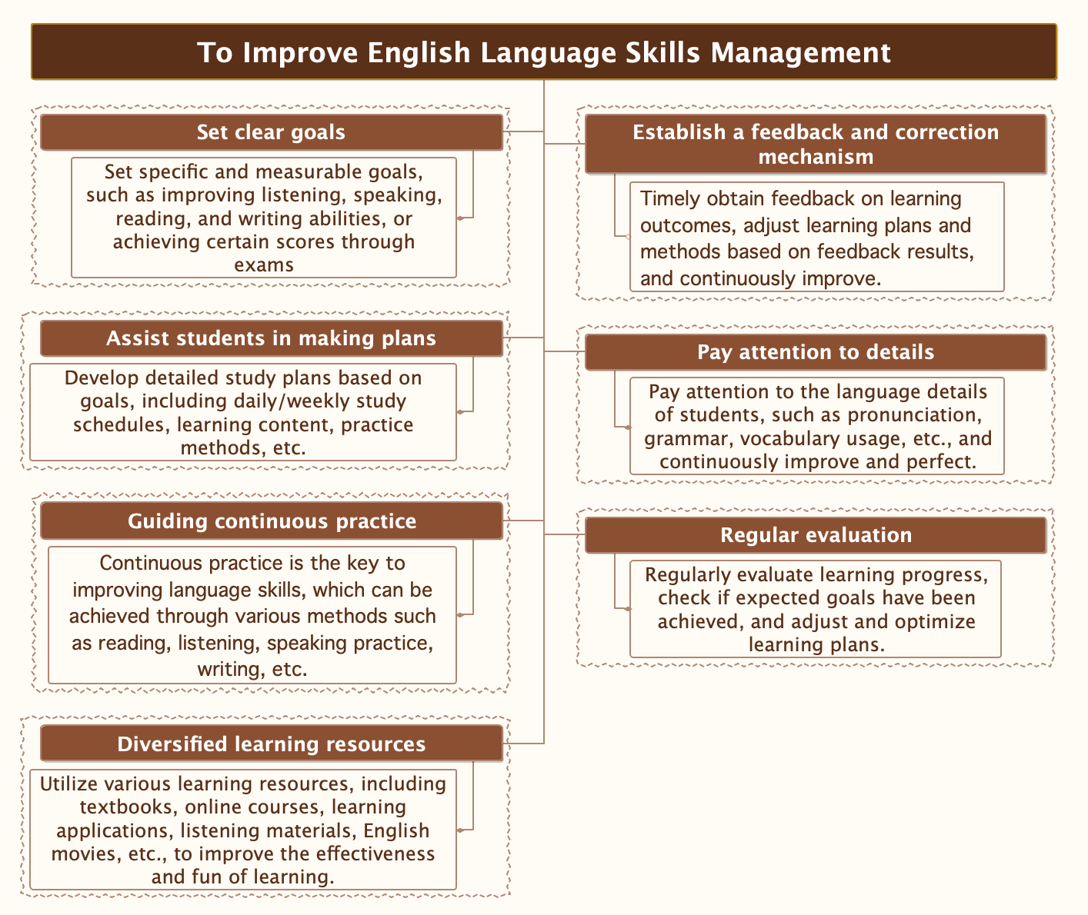

**Suggestions**

1. Strengthen the construction of the teaching staff.

To effectively enhance English teaching, schools must prioritize the ongoing construction of their teaching staff. School leaders should fully acknowledge the pivotal role of teacher-team development in improving teaching quality. Providing favorable conditions for continuous professional training, despite tight educational budgets, is crucial. Investing in teacher training is essential for long-term development. Teachers should actively pursue self-improvement, particularly in listening and speaking skills, using English as their primary teaching language and adapting to new textbook requirements.

2. During the teaching process. Create a scenario as much as possible.

Efforts should focus on enhancing students' English listening and speaking skills through flexible and creative use of textbooks. Activate textbook content in classrooms to facilitate practical application of English knowledge. This involves integrating words into discourse, combining language forms with meanings to enhance practical communication. For instance, when teaching phone call etiquette, simulate scenarios to teach patterns and idioms, enabling students to learn through performance. In conversational topics, bring physical objects to simulate roles like salespersons or customers for practice, fostering engagement and minimizing rote learning. Emphasize functional language use over repetitive reading or recitation. Employ storytelling, retelling, and questioning during text learning to cultivate listening and speaking abilities effectively.

3. Adopting different teaching methods for different majors

The requirements for English vary among different majors, and for vocational school students, their foundation is relatively weak. Therefore, it is necessary to handle the teaching materials reasonably according to the student's major, emphasizing the English vocabulary and sentence structures that students often encounter in their future work. For the learning of the professional terms contained therein, selective teaching should be carried out according to the student's preferences.

**References**

Cui H. (2024). Research on strategies to enhance the self-confidence of senior vocational students in deep foreign language learning under the perspective of positive.

Cui, N. (2023). Innovative methods of English education and teaching in higher vocational colleges in the new media era. *English Square*. 1009-6167 (2023) 20-0112-04.

Wan, M. (2024), A. Dilemmas and countermeasures encountered by higher vocational English education in the era of information sharing, 2096-711X (2024) 02-0081-03.

Wang, B. (2024) Research on the Current Situation and Countermeasures of English Communicative Ability of Intermediate Students. Journal of PR World, 2024 (05):157-159.

Yang, B. (2024) Construction of college English ubiquitous learning under the digital transformation of education. *Journal of Science and Education*. DOI 10.16871/j.cnki.kjwh. 2024.02.005. 20-23.

Yu, T. (2023). Exploring the quality improvement path of higher vocational English education from the perspective of international talent training. *Journal of Southern Vocational Education*.2095- 073X (2023)03-0091.