The Effectiveness of a Practical Framework Under the Growing Circle Theory Through the Aesthetic Education of Advertising
Art Design Students in Guizhou Urban Vocational College.
Tianjing Wang¹Thanaphan Boonyaratklin²
Guizhou Urban Vocational College, China¹
Shinawatra University, Faculty of Liberal Arts, Thailand²

ABSTRACT
This study aimed to verify the effectiveness of a practical framework based on the "Growing Circle" theory in aesthetic education for Advertising Art Design students at Guizhou Urban Vocational College, and explore differentiated effects across student characteristics. A mixed-methods research design was adopted, involving 195 students (39 freshmen, 73 sophomores, 83 juniors) through stratified random sampling. Quantitative data were collected via questionnaires and artwork evaluations, analyzed using SPSS 26.0 for descriptive statistics, t-tests, and ANOVA; qualitative data were obtained from semi-structured interviews with 28 typical students. Results indicated the framework achieved a moderate-to-high effectiveness level (overall mean > 3.6), with the highest improvement in aesthetic inclusiveness (M=3.72) and significant differences across grades, professional foundations, and genders (p<.05). Key constraints included insufficient hierarchical teaching and theory-practice disconnection. Corresponding optimization strategies were proposed, providing operable guidance for vocational college aesthetic education reform.

Keywords: Growing Circle Theory, Aesthetic Education, Advertising Art Design, Vocational College Students, Practical Framework, Resilience

INTRODUCTION
In China’s deepening quality-oriented education reform, aesthetic education has emerged as a core component of comprehensive talent cultivation, valued for its dual role in enhancing artistic literacy and shaping psychological resilience (Li & Wang, 2025; Ministry of Education of China, 2025). For Advertising Art Design students in vocational colleges, who face increasing industry demands for creative inclusiveness and frustration tolerance, traditional "geometric perfection" aesthetic education overemphasizing standardized skills while neglecting psychological growth has become inadequate (Zhang, 2025).
The "Growing Circle" theory, centered on "facing imperfection, accepting imperfection, and polishing imperfection", aligns with the reform needs of vocational aesthetic education. It guides individuals to achieve psychological maturity and ability improvement through embracing flaws, which is particularly relevant for students navigating professional skill development and psychological maturation (Chen et al., 2025). However, existing research lacks targeted empirical verification of this theory in vocational Advertising Art Design education, and no complete practical framework has been established to bridge theoretical concepts with classroom practice (Zhang Lei, 2025; Smith, 2025).
To address this gap, this study constructed a four-stage practical framework (Cognitive Acceptance → Practical Trial and Error → Reflective Optimization → Growth Upgrade) based on the "Growing Circle" theory. By verifying its effectiveness and analyzing influencing factors, this research aims to provide a scientific basis and operable strategies for optimizing aesthetic education in similar vocational college programs.

LITERATURE REVIEWS
Theories Related to the Study Satisfaction Theory Satisfaction theory posits that student satisfaction with teaching activities is closely linked to ability cultivation effectiveness, with teaching content alignment to student needs as a core influencing factor (Zhao & Wang, 2025). In aesthetic education, satisfaction encompasses not only content and method evaluation but also psychological perceptions of creative growth (Yang, 2025). Oliver’s (2019) expectation confirmation theory further suggests that when students’ actual growth from overcoming creative setbacks exceeds expectations, their satisfaction with aesthetic education significantly improves providing an evaluation perspective for this study’s framework effectiveness assessment.
Student Management Theories
Student Management Theories emphasize personalized management aligned with creative personalities and growth laws (Chen, 2024). Maslow’s Hierarchy of Needs Theory highlights the importance of meeting esteem and self-actualization needs through recognizing creative progress (Maslow, 2018), while Drucker’s Goal Management Theory supports phased aesthetic education objectives aligned with the "Growing Circle" logic (Drucker, 2021). These theories provide practical paths for integrating the "Growing Circle" theory into aesthetic education, emphasizing flexible management and hierarchical incentives.
The "One-Size-Fits-All" Paradigm in Education
The "one-size-fits-all" teaching model, which ignores differences in student grades and professional foundations, contradicts the "hierarchical growth" logic of the "Growing Circle" theory (Wang, 2025). In vocational art education, this paradigm leads to unbalanced learning outcomes students with weak foundations struggle to apply theory, while advanced students lack room for deepening (Zhang, 2025) underscoring the need for differentiated teaching design.
Related Research on the Title
Research on the "Growing Circle" theory in education has confirmed its effectiveness in reducing creative anxiety and improving autonomous learning (Zhang Lei, 2025), but lacks focus on vocational Advertising Art Design scenarios. Foreign studies (Smith, 2025) have focused on basic education, with limited applicability to vocational students’ career-oriented needs. Studies on aesthetic education optimization for advertising design majors (Jones, 2021) emphasize industry demand alignment but neglect psychological resilience cultivation. Research on resilience and aesthetic inclusiveness (Davis, 2019) highlights the importance of tolerant creative environments but lacks integration with professional teaching frameworks. This study addresses these gaps by constructing a targeted practical framework and verifying its effectiveness through empirical research.

RESEARCH METHODOLOGY
Research Objectives
1)Verify the effectiveness of the "Growing Circle" theory-based practical framework in improving Advertising Art Design students’ resilience and aesthetic inclusiveness.
2)Analyze differentiated effectiveness across student characteristics (gender, grade, professional foundation).
3)Propose optimization strategies addressing key constraints in framework implementation.
Population and Sample
The population included 195 full-time Advertising Art Design students at Guizhou Urban Vocational College (39 freshmen, 73 sophomores, 83 juniors). A full-sample questionnaire survey yielded 188 valid responses (effective rate 96.4%). Stratified random sampling selected 86 students for a 16-week quasi-experiment (43 in experimental group, 43 in control group), with no significant pre-test differences in professional foundation or aesthetic ability (p>.05). Twenty-eight typical students were selected for semi-structured interviews and artwork evaluation.
Research Tools
1)Questionnaire: Included 35 items (5 demographic, 30 Likert-scale satisfaction items, 5 open-ended questions) to measure resilience, aesthetic inclusiveness, and framework satisfaction. Cronbach’s α coefficient was 0.836, indicating good reliability; IOC scores of core items ≥0.8, confirming content validity.
2)Semi-structured Interview Outline: Designed for three grades, exploring students’ theory acceptance, creative psychological changes, and teaching suggestions.
3)Artwork Evaluation Scale: Developed by professional teachers and industry experts, evaluating 5 dimensions (aesthetic expression, creative thinking, professional skill application, problem-solving ability, growth potential) on a 10-point scale.
Data Collection
Data collection spanned three stages
Preliminary stage (Week 1): Baseline survey on resilience and aesthetic inclusiveness.
Middle stage (Week 8): Phased practice data collection (work samples, classroom performance) for intervention adjustment.
Later stage (Week 16): Post-intervention survey, final work collection, and interviews for effect comparison.
Data Analysis
Quantitative Analysis: SPSS 26.0 was used for descriptive statistics (frequency, percentage, mean, SD), paired sample t-tests (pre-test vs post-test), and one-way ANOVA (differences across groups).
Qualitative Analysis: Interview records and work analysis reports were coded to extract core themes, exploring the theory’s influence mechanism.

RESULTS OF RESEARCH
Students’ Cognition and Attitude
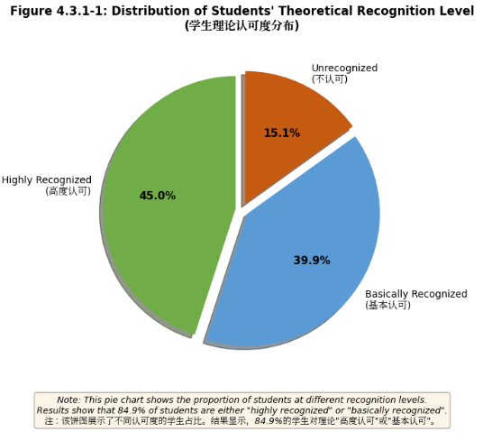
Figure 1 Distribution of Students' Theoretical Recognition Level
Figure 1 note: This pie chart shows the proportion of students at different recognition levels. 45.0% highly recognized, 39.9% basically recognized, 15.1% unrecognized.
Figure 1 shows 84.9% of students "highly recognized" (45.0%) or "basically recognized" (39.9%) the "Growing Circle" theory. Grade differences in students’ cognition and participation willingness further reflect the necessity of hierarchical teaching (Figure 2). Freshmen had the highest theoretical cognition (M=4.12), while sophomores showed the strongest participation willingness (M=3.72).

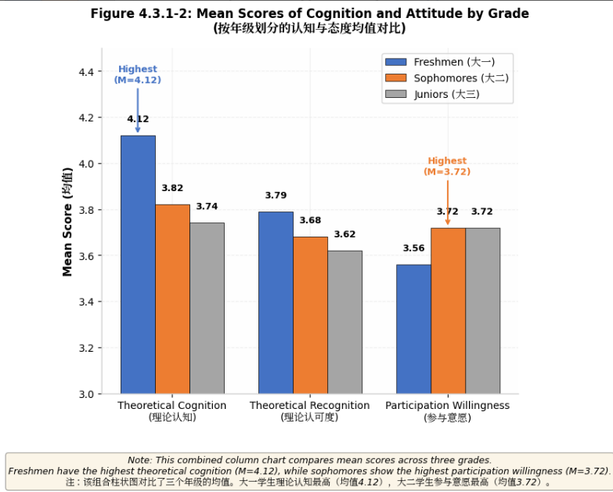
Figure 2 Mean Scores of Cognition and Attitude by Grade
Figure 2 note: This combined column chart compares mean scores of theoretical cognition, recognition, and participation willingness across grades.
Application Effect of the "Growing Circle" Theory
Quantitative Results
The framework’s overall effectiveness was moderate-to-high, with aesthetic inclusiveness (M=3.65) leading, followed by learning mentality (M=3.78) and professional creation ability (M=3.71). Among aesthetic inclusiveness sub-dimensions, diversified aesthetic cognition scored highest (M=3.72), while audience aesthetic adaptation was lowest (M=3.59) (Figure 3).Significant differences were found across professional foundations: students with excellent foundations showed the highest improvement (M=0.95), followed by medium (M=0.72) and weak (M=0.65) (Figure 4). Independent samples t-tests confirmed experimental group post-test scores (resilience: 3.98±0.45; aesthetic inclusiveness: 3.85±0.41; professional creativity: 3.82±0.48) were significantly higher than the control group (p<.001) (Table 1).

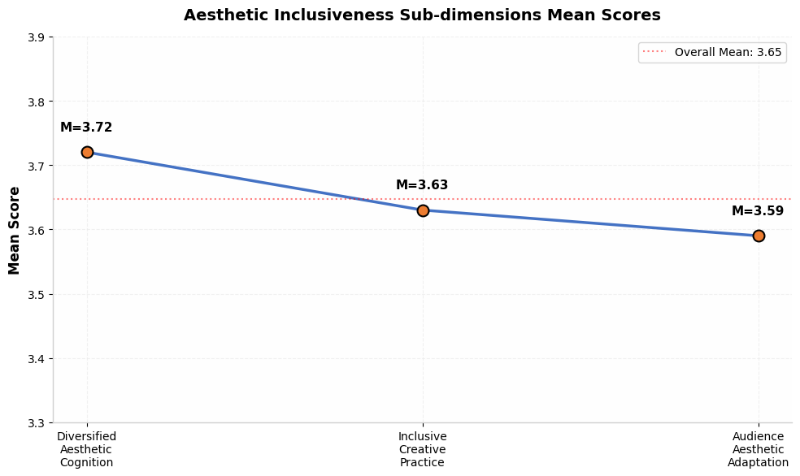
Figure 3 Sub-dimensions of Aesthetic Inclusiveness
Figure 3 note: This line chart shows mean scores of three sub-dimensions: diversified aesthetic cognition, inclusive creative practice, audience aesthetic adaptation.
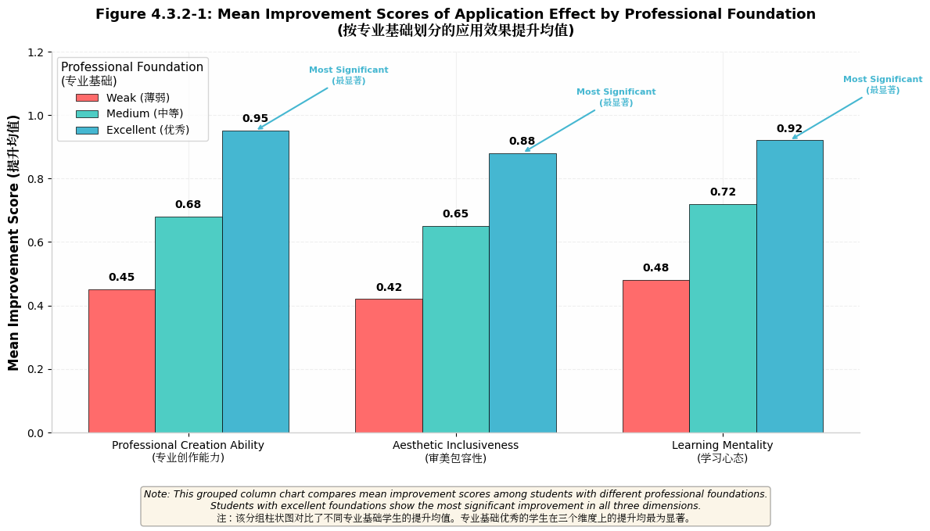
Figure 4 Mean Improvement Scores of Application Effect by Professional Foundation
Figure 4 note: This grouped column chart compares improvement scores across professional foundation levels, with students with excellent foundations showing the most significant improvement (M=0.95).

Variables | Experimental Group  (n=43) | Control Group  (n=43) | t-value | p-value
Resilience | 3.98 ± 0.45 | 3.22 ± 0.58 | 7.02 | < 0.001
Aesthetic Inclusiveness | 3.85 ± 0.41 | 3.10 ± 0.52 | 7.45 | < 0.001
Professional Creativity | 3.82 ± 0.48 | 3.15 ± 0.55 | 6.58 | < 0.001
Table 1 Comparison of Post-test Scores Between Experimental and Control Groups (M±SD)
Qualitative Results (The Missing Piece Practical Training)
78.3% of students integrated "imperfect elements" into creative works (posters, illustrations, storyboards). Four typical storyboard sets interpreted "imperfect growth" from perspectives of choice, mutual reflection, persistence, and the cost of perfection. Quality distribution showed 29.8% excellent, 48.5% good, 18.6% qualified, and 3.1% unqualified works (Figure 5). Teacher evaluation averaged 7.9/10, with 71.2% of students highly recognizing the training (Table 2).
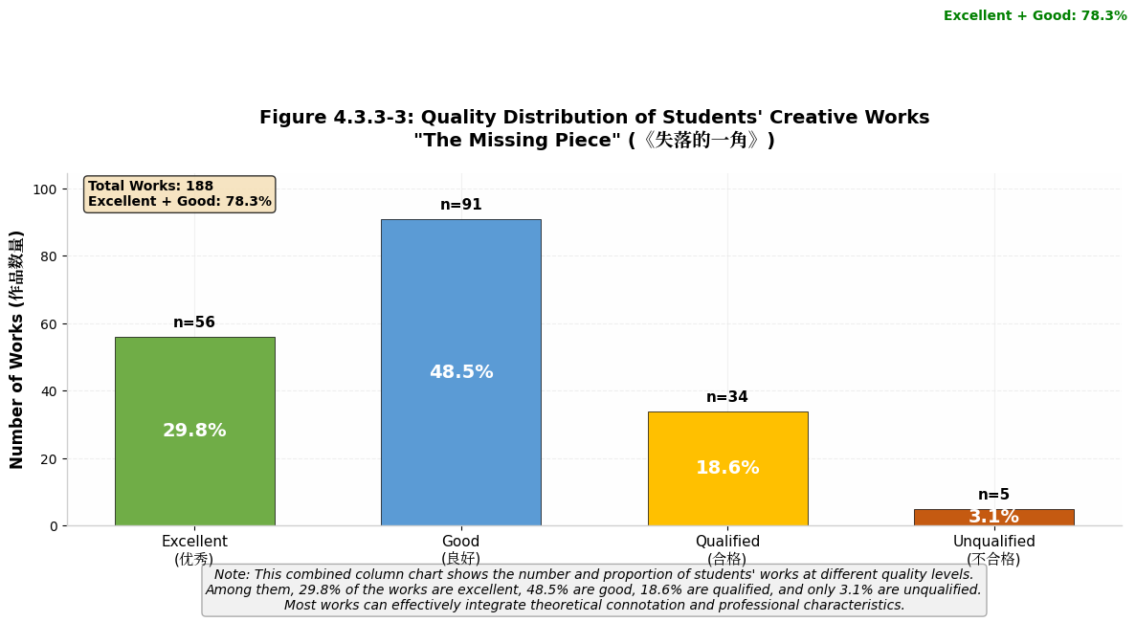
Figure 5 Quality Distribution of Students' Creative Works
Figure 5 note: This combined column chart shows the number and proportion of works at different quality levels.

Aspect | Freshmen | Sophomores | Juniors | Overall
Highly Recognized (%) | 62.2 | 78.6 | 72.8 | 71.2
Basically Recognized (%) | 29.7 | 18.6 | 22.2 | 23.4
Unrecognized (%) | 8.1 | 2.8 | 5.0 | 5.4
Teacher Evaluation (10) | 7.2 | 8.5 | 8.1 | 7.9
Table 2 Evaluation of The Missing Piece Practical Training
Existing Problems and Constraints
1)Theory-Practice Disconnection: 37.2% of students reported abstract theoretical teaching; 21.7% failed to integrate "imperfect growth" connotation into works.
2)Lack of Targeted Teaching: Freshmen (high theoretical cognition, weak practice) and juniors (rich practice, low theoretical cognition) showed unbalanced development.
3)Inadequate Evaluation System: Final works accounted for 70% of evaluation, neglecting process-oriented indicators.
4)Insufficient Support System: 63.5% of students cited lack of creative display platforms; 62.3% of teachers lacked industry practical experience.

DISCUSSION AND CONCLUSION
Research Findings
The "Growing Circle" theory-based practical framework effectively improves Advertising Art Design students’ resilience, aesthetic inclusiveness, and professional creation ability, with significant differences across professional foundations, grades, and genders. This aligns with the core logic of the "Growing Circle" theory (imperfection promotes growth) and Perception Theory (cognitive transformation drives creative behavior) (Goleman, 2019). Compared with domestic research (Li, 2024), this study visualizes abstract theory through practical training, enhancing operability; unlike foreign general education studies (Silverstein, 1976), it combines vocational professional characteristics, filling the research gap.
Optimization Strategies
Curriculum and Teaching Design
1)Hierarchical Teaching Implementation: Design differentiated modules for freshmen (theoretical cognition + basic practice), sophomores (creative trial and error + skill improvement), and juniors (industry project application + reflective optimization).
2)Theory-Practice Integration: Embed "imperfect aesthetic" application into core courses (advertising creative design, visual communication) with specific tasks (e.g., "imperfect element poster creation").
Resource and Support Enhancement
1)Platform Construction: Establish creative display platforms (e.g., "Growing Circle" works exhibition) and industry cooperation bases for real project practice.
2)Teacher Development: Provide training on the "Growing Circle" theory and industry trends, encouraging participation in professional projects.
Evaluation System Improvement
Implement a multi-dimensional evaluation system (process: 50%, final work: 50%) including theoretical understanding, trial-and-error records, and work optimization trajectory.
Limitations and Future Research
This study was conducted in a single vocational college, limiting result generalizability. Future research could expand to multi-regional samples and extend the research cycle to track long-term career development impacts. Additionally, integrating emerging technologies (AI design tools) into the practical framework could enhance its adaptability to industry changes.

REFERENCE
Bennett, E. (2025). Mixed methods research in aesthetic education: Practical guidelines for vocational college studies. Journal of Educational Research and Practice, 41(2), 56–71.
Chen, L., et al. (2025). Application of “Growing Circle” theory in vocational art education. Vocational and Technical Education, 46(5), 68–73.
Drucker, P. (2021). The practice of management. HarperCollins Publishers.
Goleman, D. (2019). Emotional intelligence. Bantam Books.
Jones, J. (2021). Industry demand-oriented aesthetic education optimization for advertising design majors. Journal of Vocational Education, 38(2), 34–42.
Li, J., & Wang, Y. (2025). Longitudinal study on the impact of aesthetic education on vocational college students’ psychological resilience. China Journal of Education, 12, 45–51.
Maslow, A. (2018). Motivation and personality. HarperCollins Publishers.
Ministry of Education of China. (2025). Guidelines for strengthening aesthetic education in vocational colleges (Ministry of Education Official Document [2025] No. 18).
Oliver, R. (2019). Satisfaction: A behavioral perspective on the consumer. Routledge.
Silverstein, S. (1976). The missing piece. HarperCollins Publishers.
Smith, J. (2025). Growing Circle theory in basic art education. International Journal of Art Education, 42(3), 31–40.
Yang, J. (2025). Dynamic evaluation of aesthetic education satisfaction in art majors. Art Education Research, 32(7), 7–10.
Zhang, H. (2025). Current status and reform paths of aesthetic education in vocational advertising art design majors. Vocational Education Research, 18(3), 56–62.
Zhang, L. (2025). Four-stage teaching model based on Growing Circle theory. Journal of Art Education, 28(4), 23–28.
Zhao, H., & Wang, B. (2025). Student satisfaction in vocational aesthetic education. Journal of Guizhou Urban Vocational College, 13(2), 5–8.

