TRANSFORMATION OF CONTEMPORARY CHINESE TRADITIONAL LUNAR FLOWER PATTERNS IN THE DESIGN OF LACQUER EARRINGS FOR YOUNG AND MIDDLE-AGED CONSUMERS
Yanxian Fan¹
¹Academy of Arts and Philosophy, Shinawatra University
E-mail: fanyanxian2024@163.com¹
Abstract
This study investigates the contemporary transformation of traditional Chinese lunar floral patterns in lacquer earrings design, with a focus on meeting the aesthetic and cultural preferences of young and middle-aged consumers. Deeply rooted in China’s traditional calendrical culture, lunar floral motifs embody rich symbolic meanings and aesthetic values. This research aims to explore how these traditional patterns can be reinterpreted and integrated into contemporary lacquer earrings design to respond to modern design sensibilities and cultural consumption trends. A qualitative research methodology is adopted, including literature review, visual culture analysis, and practice-based design research. The study emphasizes the interpretation of symbolic meanings embedded in traditional lunar floral patterns, alongside material exploration and experimental ear pendant design practice.
The findings demonstrate that through formal abstraction, material innovation, and contemporary design strategies, traditional lunar floral patterns can be effectively transformed into lacquer earrings designs that preserve cultural identity while appealing to contemporary consumers. The research confirms the feasibility and cultural significance of applying traditional Chinese lunar motifs within modern lacquer earrings design. Furthermore, it highlights the value of integrating traditional cultural symbolism with modern design thinking and material experimentation, and demonstrates that practice-based design research can serve as an effective bridge between traditional culture and contemporary jewelry design. This study contributes to the sustainable development and contemporary dissemination of traditional Chinese ear pendant design.
Keywords: Chinese lunar floral patterns, Lacquer earrings design, Contemporary design transformation, Cultural heritage innovation, Young and Middle-Aged Consumers.
Introduction
Traditional Chinese lunar culture represents a highly structured temporal system that extends beyond calendrical measurement to encompass philosophical thought, social order, and aesthetic perception. Since the seasonal prescriptions documented in the Book of Rites (Liji · Yueling), the Chinese worldview has conceptualized time as an organic process shaped by the dynamic relationship between humans and nature. This perspective reflects the philosophical principle of the unity of heaven and humankind, emphasizing balance, cyclical transformation, and ecological harmony(Ying, 2018).
Within this cultural framework, floral motifs function as a symbolic medium through which seasonal change is visually articulated. Each flower is associated with a specific lunar month and conveys culturally embedded meanings: the plum blossom signifies resilience, the peony represents prosperity, and the lotus embodies moral purity. Rather than serving merely decorative purposes, these motifs operate as carriers of collective memory and cultural identity.
Historically, lunar floral imagery evolved into a coherent visual language widely applied across traditional crafts, including ceramics, textile arts, metalwork, and lacquerware. Particularly during the Ming and Qing dynasties, floral ornamentation became a defining feature of artistic production. However, processes of modernization and industrialization have increasingly distanced such symbolic systems from contemporary daily life. As a result, traditional floral culture now faces the risk of semantic erosion, wherein motifs survive as stylistic references while their cultural depth gradually diminishes.
Simultaneously, globalization has intensified concerns regarding cultural homogenization, prompting renewed scholarly and creative interest in heritage revitalization. In design disciplines, this has generated an ongoing tension between cultural preservation and contemporary innovation. Designers are challenged not only to maintain recognizable cultural characteristics but also to respond to evolving aesthetic expectations and modes of consumption(Guo et al, 2025).
Recent studies suggest that younger generations of consumers increasingly value culturally meaningful products that support identity construction while aligning with modern lifestyles. The growing popularity of the “New Chinese Style” reflects a broader shift away from superficial historicism toward interpretive transformation—one that extracts essential cultural logic rather than replicating traditional forms. This transition signals an important opportunity for design to act as a mediator between historical continuity and contemporary relevance.
Among traditional materials, lacquer holds particular significance due to its technical sophistication and cultural resonance. Its tactile warmth, chromatic depth, and capacity to develop a patina over time embody a sense of material vitality closely aligned with the temporality embedded in lunar culture. When applied to jewelry objects intimately connected to bodily presence and self-expression—lacquer offers a compelling platform for translating cultural symbolism into wearable artifacts(Xiao et al, 2024). Contemporary jewelry has increasingly moved beyond ornamentation to function as a narrative device through which personal and cultural identities are negotiated.
Despite growing academic attention to cultural heritage innovation, existing scholarship has largely focused on historical analysis or preservation strategies, with comparatively limited exploration of systematic design methodologies for transforming traditional symbolic resources into contemporary artifacts. In particular, the application of lunar floral motifs within modern lacquer earrings remains underexamined. This gap highlights the need for research that integrates cultural interpretation, material experimentation, and design practice within a coherent methodological framework.
To address this gap, the present study adopts a practice-based research approach to investigate how traditional Chinese lunar floral patterns can be reinterpreted through contemporary design strategies. Specifically, the research seeks to decode the cultural semantics of these motifs, translate their visual structures into modern design language, and validate the feasibility of this transformation through lacquer earrings practice.
The study contributes to design research in three principal ways. First, it proposes a cultural semantic framework that supports the systematic reinterpretation of traditional motifs. Second, it develops an integrative “culture–design–user” model that bridges theoretical analysis and creative production. Third, it demonstrates how practice-based inquiry can function as a form of knowledge generation, enabling designers to engage critically with heritage while producing culturally distinctive outcomes.
By positioning design as an interpretive act rather than a process of stylistic reproduction, this research reframes traditional culture as a dynamic resource for innovation. In doing so, it supports broader discussions on cultural sustainability and offers methodological insights for designers seeking to navigate the intersection of heritage and contemporary creative practice.

Objective
The objectives of this research are threefold:
- to analyze the cultural semantics and visual structures of traditional Chinese lunar floral patterns;
- to develop a systematic design methodology that supports the contemporary transformation of these motifs; and
- to validate the feasibility of this methodology through practice-based lacquer earrings design.

Literature Review

1. Research on Lunar Floral Motifs
Scholarly inquiry into lunar floral motifs has accumulated substantial knowledge both domestically and internationally; however, the majority of studies remain situated within historical and cultural analysis. argues that Chinese floral patterns are characterized by pronounced symbolic attributes and semantic depth, functioning not merely as decorative forms but as a visual language embedded with cultural meaning(Ruan, 2023). Their symbolic system demonstrates relative stability while reflecting anthropomorphic ethics, social hierarchy, and broader cultural values.
From the perspective of visual language, researchers generally agree that traditional Chinese floral motifs exhibit distinctive structural characteristics. These include the construction of rhythmic harmony through curvilinear forms, an emphasis on linear organization and compositional cadence, and the frequent use of symmetrical, radial, or continuous arrangements. Moreover, such motifs prioritize stylization and abstract imagery, embodying what has been described as “symbolic abstraction” rather than naturalistic representation. further proposes that traditional Chinese ornamentation reflects an aesthetic paradigm of symbolic abstraction, in which visual form is less concerned with realism than with communicating cultural energy and maintaining symbolic continuity.
Despite these insights, existing scholarship has predominantly focused on two-dimensional or large-scale media such as painting, architecture, and textiles. Comparatively little attention has been given to jewelry, a small-scale medium that interacts dynamically with the human body. The challenge of preserving cultural recognizability within limited spatial dimensions while simultaneously achieving contemporary aesthetic translation remains insufficiently explored. Addressing this issue constitutes a central concern of the present study(Subedi & Hamal, 2023).
2. Developments in Lacquer Art and Contemporary Jewelry Design
Lacquer art, one of China’s most representative traditional crafts, embodies over eight millennia of technical evolution and cultural accumulation. observes that the stratification, temporality, and luminosity of natural lacquer render it a material capable of “recording time.” The repetitive processes of coating and polishing effectively layer temporal traces onto the object, while chromatic transformation and phenomena such as lacquer cracking impart a sense of material vitality(Xiao等, 2024b). This notion of lacquer as a “living material” forms a philosophical parallel with the cyclical understanding of time embedded within lunar culture.
Research in contemporary jewelry design indicates an ongoing expansion beyond conventional boundaries of material, form, and function. Increasingly, designers emphasize innovative applications, interdisciplinary integration, personalized expression, and sustainability. Modern consumers no longer evaluate jewelry solely in terms of material rarity but also consider the cultural meanings, artistic value, and emotional connections it conveys (Lucas & Chapin, 2015). This shift creates favorable conditions for incorporating traditional cultural elements into contemporary design practice.
Nevertheless, while both lacquer craftsmanship and jewelry design have been extensively studied, their intersection—particularly as a vehicle for cultural reinterpretation—remains underdeveloped within academic discourse.
3. Research Gaps and Opportunities for Innovation
A systematic review of the literature reveals several critical gaps that frame the necessity of this research.
First, there is a lack of methodological coherence in studies addressing media transformation. Existing research tends either to treat lunar culture as a purely theoretical subject or to examine lacquer techniques as an independent craft tradition. Few studies have systematically explored their integration through the specific medium of lacquer ear ornaments. This fragmentation limits a comprehensive understanding of how cultural symbols and craft practices can converge at the micro-design level.
Second, current scholarship demonstrates structural limitations in design methodology. Much of the literature remains confined to macro-level theoretical discussions or isolated technical case analyses, offering limited operational guidance for designers. Three issues are particularly evident: the absence of systematic methods for translating the temporal narratives of lunar culture into design language; the lack of a clearly articulated theoretical framework connecting lacquer materiality with cultural expression; and the disconnect between design practice and user-oriented research, which constrains the effective market transformation of culturally informed products.
Third, practical interdisciplinary integration remains insufficient. Lunar culture, lacquer craftsmanship, and jewelry design originate from distinct disciplinary domains, and existing studies frequently adopt single-perspective approaches without fostering meaningful cross-disciplinary dialogue. Such boundaries result in several consequences: cultural research struggles to translate into tangible design language; technological innovation risks lacking cultural depth; and design practice may become stylistically superficial due to limited theoretical grounding.
Collectively, these gaps not only highlight the necessity of the present study but also delineate a significant space for innovation. By integrating cultural interpretation, material exploration, and practice-based design, this research seeks to contribute a systematic framework for the contemporary transformation of traditional symbolic resources.

Research Methodology

1. Research Design and Methodological Framework
This study adopts a qualitative, practice-based research approach in which design practice functions simultaneously as a mode of inquiry and a form of knowledge production(Yijing & Sharudin, 2023). Within this framework, design is understood not merely as a final outcome but as an investigative process that integrates cultural interpretation, material exploration, and user-oriented evaluation. The research follows an iterative cycle of development, evaluation, reflection, and redesign, allowing insights generated through practice to continuously inform subsequent design decisions.
Six complementary methods were employed. First, a literature review systematically examined scholarship related to lunar culture, floral motifs, and lacquer craftsmanship. Second, cultural semiotic analysis was conducted to interpret the semantic structures embedded in lunar floral symbolism. Third, visual form analysis deconstructed the compositional elements and formal characteristics of traditional patterns. Fourth, expert interviews were carried out with six participants—including lacquer artisans, jewelry designers, and cultural brand practitioners—using semi-structured protocols to capture professional perspectives. Fifth, practice-based design research guided the creation of a lacquer ear ornament series inspired by lunar floral themes. Finally, design critique and reflective evaluation were undertaken through expert feedback and peer review to assess the effectiveness of the proposed design methodology.
The overall research framework follows a progressive structure: cultural foundation → expert cognition → design generation → practice validation → theoretical feedback. Beginning with the cultural semantics of lunar floral motifs, the study integrates expert insights regarding target users to inform design development. The resulting artifacts were evaluated through wearing experiences and peer assessment, enabling the extraction of theoretical implications from practical outcomes. This structure ensures a systematic transformation from cultural resources to design innovation while aligning with the process-oriented and reflective nature of practice-based design research.
2. Cultural Semantic Analysis Framework
Drawing upon (Panofsky, E. 1955) three-tier iconographic theory, this study develops an interpretive framework for analyzing lunar floral motifs. At the symbolic level, the research investigates cultural connotations, temporal philosophy, and ethical values embedded within the patterns. At the referential level, it examines the relationship between the motifs and natural rhythms, agricultural cycles, and folk traditions. At the affective level, the study explores the mechanisms through which these motifs evoke emotional resonance among contemporary consumers. The integration of these dimensions forms a semantic matrix of lunar floral culture, clarifying both the symbolic attributes of the flowers and their potential pathways for design translation(Guangzhou & Porncharoen, 2024).
Visual form analysis combines formal aesthetics with functional considerations relevant to jewelry wearers. Structural organization was examined to decode the compositional logic between primary floral elements and supporting motifs. Stylistic genealogy distinguished among realistic, abstract, and imagistic modes of representation. Rhythmic characteristics such as repetition, symmetry, and radial composition were analyzed for their capacity to reinforce the cyclical imagery inherent in lunar culture.
Color translation focused on the evolution of traditional chromatic symbolism toward contemporary neutral palettes, facilitating broader aesthetic acceptance. Additionally, scale and weight introduced a critical analytical dimension specific to ear ornaments. Based on empirical observations, lightweight construction (single-piece weight below 5 grams) and compact dimensions (diameter ≤ 3 cm) were established as key ergonomic criteria.
3. Design Practice and Transformation Strategies
The design practice employed a three-phase transformation strategy: extraction, deconstruction, and reconstruction. During the extraction phase, essential visual elements were identified from lunar floral motifs. The deconstruction phase disrupted original compositions through geometric reduction and minimalist reinterpretation. Finally, the reconstruction phase creatively integrated these transformed visual elements with lacquer materiality to generate a new design language(Zhao & Sahari, 2025).
The design process also emphasized a balance across three levels of emotional design. The visceral level was addressed through the chromatic system of lacquer and the aesthetic qualities of floral forms. The behavioral level prioritized wearing comfort and versatility in styling. The reflective level engaged the cultural symbolism of lunar traditions, encouraging contemplation of temporality and seasonal transformation. This multi-layered approach ensured that the resulting works achieved equilibrium among visual appeal, functional performance, and cultural depth.
Table 3.1 Transformation Strategy of Contemporary Artistic Patterns in the Design of China Lacquer Ears
Policy type | Specific methods(Combining lunar flower arrangements with lacquer earrings) | Design Effect/Inspiration
cultural convergence strategy | Take the moon flower as the symbol of time culture, extract the spiritual connotation of the flower (such as the plum blossom's high and noble, chrysanthemum's reclusive) to avoid specific replication. | Inheriting the Root of Traditional Culture, Jewelry Becomes a Wearable Time Narrative Carrier
formal translation policy | Abstracting Flower Structure into Linear,Geometric or Imaginative Form and Reconstructing Contemporary Form with Plasticity of Lacquerware | Discard the "old-fashioned traditional sense" to improve the contemporary aesthetic acceptance
Material and Technology Innovation | The works highlight the sense of layers and the flow of time through lacquer art techniques such as gilding, polishing and gold foil. | Strengthening the Aging of Lacquerware Materials and Forming an Intrinsic Echo with the Culture of Monthly Orders
Digital Enhanced Slides | 3D Modeling and Digital Pattern Derivation Assisted Jewelry Design and Proportion Optimization | Improving the Design Accuracy of Traditional Process and Reducing the Cost of Trial and Error
brand narrative strategy | With "December", "Flower God" and "Season" as the narrative clues of the brand, a series of visual and cultural stories are constructed. | Enhance the Cultural Identity and Strengthen the Cultural Identity of the Middle-aged and Young People
Scenario-based Communication Policy | Integrate seasonal divisions and annual milestones for product display and promotion to enhance the contextual wearing experience | Emotional Connection between Jewelry and Lifestyle
cross boundary convergence strategy | The combination of lacquer earrings with modern metal, gemstone and sustainable materials | Expanding Process Performance Boundary and Enhancing Market Adaptability

Research Results

1. Contemporary Expression of the Lunar Floral Symbolic System
Design practice demonstrates that flowers associated with the lunar calendar function not merely as decorative botanical motifs but as temporal cultural symbols that embody sequential time, seasonal rhythm, and collective memory. In practical application, these floral cycles are interpreted not as natural entities but as symbolic units imbued with cultural meaning.
Jewelry inspired by the plum blossom of the first lunar month employs restrained composition, deliberate negative space, and subdued chromatic schemes, aligning with the contemplative spiritual qualities traditionally associated with winter. In contrast, peony-themed jewelry adopts fuller compositions and soft gradient colors to articulate the vitality and prosperity symbolizing spring. Such differentiated design languages not only highlight the inherent seasonality embedded within jewelry form but also reinforce the rhythmic beauty of floral transformation across temporal cycles.
The findings further indicate that jewelry, as a wearable medium, translates the cultural meanings of lunar floral motifs from static visual narratives into embodied cultural expression. When worn near the ear, floral imagery ceases to operate as an overt symbol and instead becomes subtly integrated into the wearer’s overall appearance. This suggests a contemporary design tendency toward implicit cultural communication rather than explicit representation. Such an approach aligns with the aesthetic preferences of modern young and middle-aged consumers, who favor understated interpretations of tradition that can seamlessly integrate into everyday life.

2. Morphology and Visual Language of Lacquer Ear Ornaments
Research on proportional design suggests that abstract simplification of floral forms yields significant visual clarity. Rather than meticulously replicating petal details, designers can achieve recognizable floral imagery in miniature jewelry by refining contours, optimizing structural relationships, and recalibrating proportions. The camellia-themed earrings representing the eleventh lunar month exemplify this strategy, demonstrating how contour optimization and layering techniques can effectively convey floral identity within limited spatial dimensions.
From a morphological perspective, most works adopt circular or near-disc configurations as foundational structures. These forms exhibit visual stability and inclusivity, making them effective carriers for floral motifs. Moreover, circular geometry resonates with traditional Chinese aesthetic concepts of completeness and cyclical continuity, establishing an intrinsic connection with the temporal cycles emphasized in the lunar system. This formal decision therefore achieves a balance between functional performance and symbolic significance.
In terms of color application, the designs prioritize the contemporary translation of traditional chromatic symbolism. For instance, the plum blossom series utilizes cool tones such as silver-gray, muted red, and ink black to evoke the austerity of winter, whereas the peony series incorporates warmer hues including rich red, deep violet, and gold to communicate the exuberance of spring. This chromatic strategy preserves cultural recognizability while aligning with contemporary aesthetic sensibilities.
3. Material and Craft Exploration: The Temporality of Lacquer
Design experimentation highlights the unique capacity of lacquer to articulate temporal themes. Through repeated processes of coating, polishing, and burnishing, lacquer surfaces develop layered three-dimensional textures that metaphorically correspond to the seasonal symbolism of lunar culture. The lotus-themed earrings of the sixth lunar month achieve a balance between visual presence and wearing comfort, with proportionally calibrated dimensions supporting everyday usability.
Craft techniques were found to significantly influence visual depth. The integration of lacquer with gold leaf and localized metal elements generates an outward-expanding stratification within the floral imagery. Rather than appearing as a singular exposed surface, the motifs gradually reveal themselves through shifting light and viewing angles. This enhancement of visual layering increases aesthetic engagement while reinforcing the narrative role of lacquer craftsmanship, positioning the material itself as a constituent of cultural meaning.
Material innovation further extends the expressive boundaries of lacquer by combining it with contemporary metals, gemstones, and sustainable substrates. Such cross-material integration not only broadens technical possibilities but also strengthens market adaptability. For example, several works employ environmentally responsible base materials that retain traditional visual qualities while responding to modern sustainability concerns.

4. Wearability and Adaptation to Contemporary Aesthetics
Wearability assessments indicate that the jewelry meets the practical requirements of everyday use in terms of size and weight control. The pieces achieve visual prominence while remaining lightweight, ensuring comfort without imposing perceptible strain on the wearer. This finding suggests that culturally informed jewelry can successfully reconcile symbolic expression with ergonomic functionality.
In experiential terms, the lunar floral lacquer earrings demonstrate a cohesive fusion of traditional aesthetics and modern minimalism. This cross-cultural adaptability enables the series to transcend narrowly defined cultural contexts and enhances its potential for integration into daily life. Market experts note that younger consumers tend to reject designs perceived as outdated; accordingly, the adoption of simplified forms contributes to a stronger sense of contemporaneity.
Testing further reveals that the use of wooden or other lightweight substrates allows for visually substantial earrings without increasing physical burden on the ear. Circular and disc-like configurations not only embody the philosophical notion of harmony but also improve wearing stability. Such balanced considerations reflect a design approach grounded in a nuanced understanding of user experience.

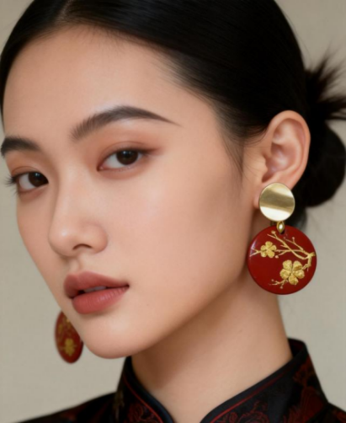

Figure 4.1January plum blossom pattern lacquer art earrings-with restrained color palette to abstract reinterpretation of floral patterns.

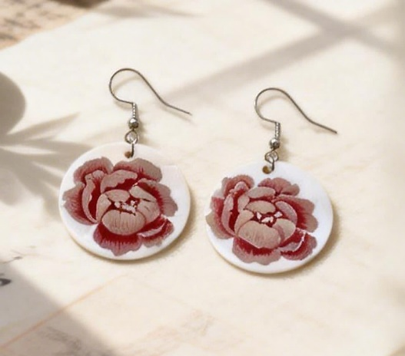

Figure 4.2 April Peony Pattern Lacquer Ears: Circular Ring Structure and Multi-layer Lacquer Surface Effect.
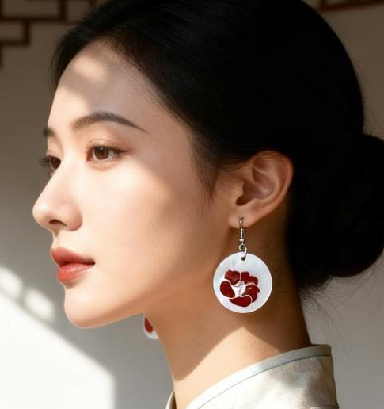

Figure 4.3 Illustration of the Detail of Camellia Flower Earrings in November-Lacquer Layer Superposition and Flower Pattern Integration Technique.

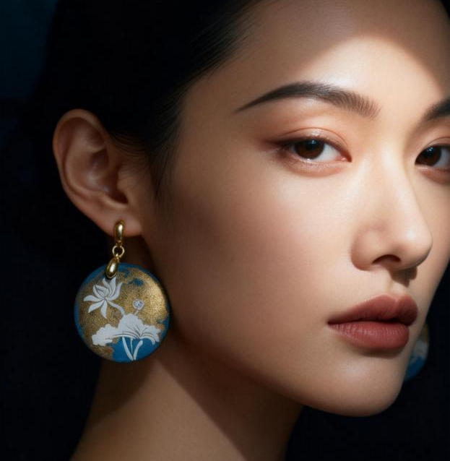

Figure 4.4 Side View of Lotus Theme Earrings in June-Displaying Size Proportion and Wearing Effect.

Discussion

1. Translating Cultural Meaning Through Design
In relation to Research Objective 1, the findings indicate that the symbolic meanings embedded within the twelve lunar flowers constitute a coherent cultural semantic system that can be systematically analyzed and translated into contemporary design language. Through the examination of cultural texts, visual motifs, and symbolic structures, the study clarifies how each lunar flower embodies specific moral values, temporal attributes, and aesthetic principles within traditional culture.
The design outcomes demonstrate that cultural symbolism can be preserved without literal replication. Strategies of selective abstraction and symbolic recoding enable continuity while allowing space for contemporary interpretation. By retaining core semantic values—such as purity, resilience, prosperity, and cyclical temporality—the lacquer ear ornaments maintain cultural integrity while achieving visual clarity and modern relevance. These findings confirm that cultural meaning can be effectively sustained through design translation rather than direct imitation.
During the process of symbolic transformation, particular attention was given to balancing tradition and modernity. For instance, plum blossom motifs were reinterpreted through linear branch structures and serrated patterns; lotus contours were simplified into curved geometries; and the complex layering of chrysanthemum petals was distilled into repetitive geometric units. This process eliminated excessive detail while enhancing formal legibility and rhythmic harmony in alignment with contemporary aesthetic expectations. Such an approach demands advanced compositional sensitivity, as designers must simplify form without compromising symbolic recognizability.

2. Morphological Transformation and Design Strategies
Addressing Research Objective 2, the study confirms that traditional floral imagery can be successfully transformed into contemporary lacquer ear ornaments suitable for young and middle-aged consumers aged 25–45. Design strategies—including geometric simplification, circular structuring, proportional control, and the deliberate use of negative space—proved critical in adapting complex traditional patterns into wearable forms.
The transformation process illustrates that contemporary wearability requires a careful equilibrium between cultural expression and functional consideration. By prioritizing visual rhythm, structural stability, and aesthetic restraint, the designs achieve compatibility with modern fashion contexts without diminishing symbolic meaning. Morphological transformation therefore operates as a mediating mechanism between cultural tradition and contemporary user expectations, enabling traditional motifs to re-enter everyday life.
At the strategic level, the study proposes a structured method of abstract recoding. Extraction serves as the foundational step, identifying the essential visual elements of lunar floral motifs. Deconstruction functions as the pivotal stage in modernizing traditional patterns, requiring a departure from naturalistic compositions through geometric reduction or minimalist reinterpretation. Reconstruction then integrates these transformed elements creatively with lacquer materiality to generate a new design language. The inherent qualities of lacquer—such as stratification, luminosity, and textural variation—provide rich possibilities for the contemporary reinterpretation of lunar floral imagery.

3．Materiality, Temporality, and Wearability
With regard to Research Objective 3, the findings emphasize the dual significance of lacquer as both a material and a conceptual medium. The layered application process, surface depth, and temporal characteristics of lacquer contribute to the expression of time, craftsmanship, and cultural continuity. Conceptually, the material properties of lacquer align with the cyclical temporality embedded in lunar culture, thereby reinforcing the symbolic dimension of the design outcomes.
Furthermore, wearability analysis confirms that lacquer ear ornaments can effectively function as everyday and semi-formal accessories when factors such as weight control, dimensional proportion, and structural balance are carefully managed. Although the evaluation relied primarily on observational analysis and documented wearing scenarios, the results convincingly demonstrate the feasibility of integrating traditional craftsmanship into contemporary wearable design. Taken together, material experimentation and ergonomic considerations validate lacquer ear ornaments as a viable medium for contemporary cultural expression.
From the perspective of emotional design, the study also verifies the applicability of (Norman, 2013) framework within lacquer earrings design. The visceral level generates immediate sensory attraction through lacquer chromatics and floral aesthetics. The behavioral level prioritizes wearing comfort and styling adaptability, supporting both daily integration and the long-term value of cultural heritage. The reflective level engages the symbolic meanings of the twelve lunar cycles, encouraging deeper contemplation of temporal passage and seasonal transformation. Consequently, lacquer ear ornaments evolve beyond decorative objects to become cultural vessels that inspire reflection on traditional heritage, natural cycles, and the broader significance of human experience.

Suggestions
Future research should explore broader applications of lunar floral motifs across diverse design categories and investigate interdisciplinary collaborations involving emerging technologies and sustainable materials. Designers are encouraged to adopt systematic methodologies when engaging with cultural resources to avoid superficial appropriation and to promote meaningful reinterpretation.
Additionally, examining user perception and international reception may enhance the global relevance of culturally grounded design. By positioning heritage as a source of innovation rather than constraint, designers can contribute to the long-term vitality of traditional culture within contemporary creative industries.

References
Guangzhou, L., & Porncharoen, R. (2024). Emotional design of traditional Chinese cultural creative products based on user demand. Journal of Graphic Engineering and Design, 15(2), 39–49. https://doi.org/10.24867/JGED-2024-2-039
Guo, H., Asliza, A., & Chen, P. (2025). Craftsmanship revitalized: Revival path of intangible heritage in modern life and cultural sustainability. Environment-Behaviour Proceedings Journal, 10(31), 275–281. https://doi.org/10.21834/e-bpj.v10i31.6488
Li, M. (2020). Aesthetic paradigm of symbolic abstraction in traditional Chinese ornamentation. Art History Quarterly, 45(1), 50.
Lucas, A., Chapin, M., Lin, M., & Jia, X. (2015). The Chinese soul in contemporary jewelry design. Gems & Gemology, 51(1), 18–30. https://www.gia.edu/gems-gemology/spring-2015-chinese-soul-contemporary-jewelry-design
Norman, D. A. (2013). The design of everyday things: Revised and expanded edition. Basic Books. https://openlibrary.telkomuniversity.ac.id/home/catalog/id/117488/slug/the-design-of-everyday-things-revised-and-expanded-edition.html
Panofsky, E. (1955). Meaning in the visual arts: Papers in and on art history. Doubleday.
Ruan, Y. (2023). Exploring the symbolism and cultural importance of Dunhuang lotus motifs. International Journal of Education and Humanities, 10(3), 22–24. https://doi.org/10.54097/ijeh.v10i3.11785
Subedi, A., & Hamal, S. (2023). The impact of different flowers on human psychology: A comprehensive review. Malaysian Mental Health Journal, 2(2), 36–38. https://doi.org/10.26480/mmhj.02.2023.36.38
Xiao, Y.-M., Shen, J.-S., & Lin, C.-L. (2024). Exploring on the extraction of attributes of lacquer art fashion products. Creative Education, 15(4), 617–642. https://doi.org/10.4236/ce.2024.154038
Yijing, C., & Sharudin, S. A. (2023). The integration of traditional symbols and modern product design: Cultural inheritance and innovation. Global Journal of Emerging Science, Engineering & Technology, 1(1), 19–25. https://doi.org/10.56225/gjeset.v1i1.17
Ying, W. (2018). A national flower’s symbolic value during the Tang and Song dynasties in China. Space and Culture, 21(1), 46–59. https://doi.org/10.1177/1206331217749765
Zhang, L. (2019). The symbolic attributes and semantic depth of Chinese floral patterns. Journal of Visual Culture, 12(3), 123.
Zhao, Q., & Sahari, F. (2025). Generating the Tang dynasty’s floral medallion motifs using shape grammar for innovative applications. Journal of Lifestyle and SDGs Review, 5(3), e05122. https://doi.org/10.47172/2965-730X.SDGsReview.v5.n03.pe05122

