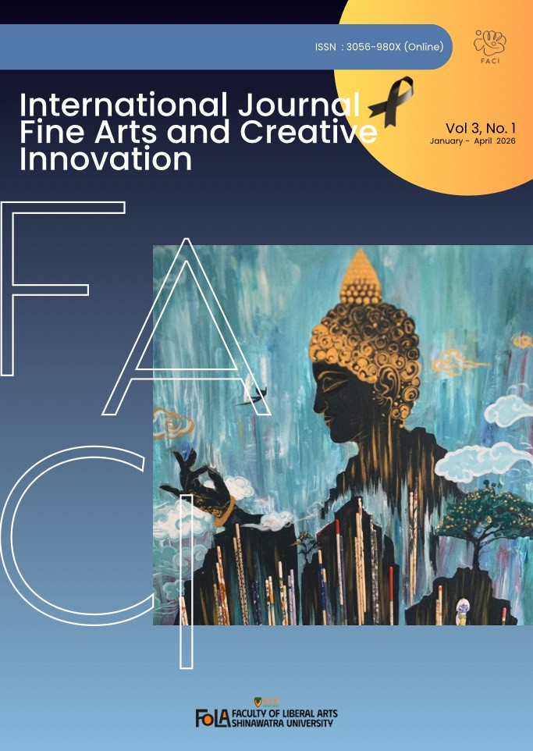

International Journal Fine Arts and Creative Innovation
Volume 3, No 1 January – April 2026

International Journal Fine Arts and Creative Innovation are created to promote and support the dissemination of work to faculty members, academics, researchers, students, and the general public. Artists and art enthusiasts around the world have the opportunity to publish academic works and research covering all types of creative arts, invention, innovation, product innovation, innovative artistic processes, educational innovations, and more.

Objectives:
International Journal Fine Arts and Creative Innovation has a policy of supporting researchers, academics, faculty, and students both internally and externally. It serves as a platform for exchanging academic knowledge, research, and creative work. It provides a space for expressing opinions, debates, and criticisms regarding art and culture. Innovations in various sciences bring benefits to the public in various areas, including:
- Visual arts
- Design
- Philosophy and aesthetics
- History and archaeology
- Mixed media art and design
- Art and photography, digital art, and animation
- Music and performance, dance studies
- Film art
- Communication design
- Other areas related to art and design

Journal Owner:
Faculty of Liberal Arts, Shinawatra University

 | Cover : Art design  Affiliation : Lecturer of Faculty of Liberal Arts, Shinawatra University  Name of Image : The light of the candle of Dharma  Type : 2D Image  Technique : Acrylic Paint  Size : 60x80 Centimeters

International Journal Fine Arts and Creative Innovation Office
99 Faculty of Liberal Arts, Moo 10, Bangtoey, Samkhok, Pathum Thani 12160, Thailand

Advisors Board
Assoc. Pro. Dr. Zhou Fei President of Shinawatra University
Dr. Fueangfa Amponsathira Vice President for Academic Affairs
Assoc. Pro. Nuanyai Pitchat Vice President for Nursing
Assoc. Pro. Dr. Ratthabut Khumsap Vice President for Special Affairs
Asst. Pro. Dr. Panphon Rodloythuk Vice President for Administration
and Student Affairs

Editor-in-chief
Dr. Chanyanan Somthawinphongsai Dean of Faculty of Liberal Arts

External Editorial Board
Prof. Wiboon Leesuwan Specialist in visual arts and folk art,
President of the Royal Academy
Prof. Preecha Thaothong National artist who has been honored
as national artist Visual arts field
Mr. Amrit Chusuwan National artist and
Vice President of Silpakorn University
Assoc. Prof. Dr. Kowit Khanthasiri Expert in Thai and international music,
Shinawatra University
Assoc. Prof. Panth Pleumchusak Expert in art and design
Assoc. Prof. Dr. Panu Suaysuwan Fine Arts Expert, Burapha University
Mr. Sakon Taoklam Deputy Dean for Student Affairs,
Faculty of Liberal Arts
Kasem Bundit University
Asst. Pro. Sittikorn Thepsuwan Communication science specialist
Mrs. Napat Albertt Engineering expert
Wu Xiaoyan Suzhou University of Science and Technology,
Art and Design
Dai Guangkai Suzhou Top Information Technical
College China
Qin Luo Sichuan Vocational
College of Culture & Communication
Mr. XINYU WANG Chinese language website in Thailand
Prof. Ramakrushna Pradhan Professor & Dean, School of Social Science Chair
Professor, Mahima Guru Chair Coordinator, The Office of International Affairs
Prof. Sunil Kumar Padhi Professor of Economics
Rajkumar Nagwanshee Professor of Economics

Internal Editorial Board
Dr. Chanyanan Somthawinphongsai Editorial Director
Asst. Prof. Dr. Thanaphan Bunyaratkalin Deputy Director
of the Editorial Department
Assoc.Prof.Dr.Jaipak Burapachattana
Assoc. Prof. Dr. Dowroong Watcharinrat
Mr. Thanit Limpaphan
Asst. Prof. Dr. Ekkarat Charoennit
Asst. Prof. Bunyakhomsan Ruangthathaworn
Ms.Thanida Wisitudonkan

Secretary
Ms. Ninlaya Meesri
Ms. Chanisara Vorayotha
Mr. Suriya Mulinin

Fine Arts Committee
Mr. Worawit Kaewsrinam
Ms. Nilaya Meesri
Ms. Silalai Phadbok

Operations Committee
Ms. Sirinthip Yodsanaeha Mr. Natthaphisit Phlapkhachorn
Ms. Ariya Atthawutthikul Ms. Silalai Phadbok
Mr. Warin Ngernlad Mr. Thatbodin Bunnueng
Mrs. Wannika Kerdbang
Mr. Phillip Albert

Peer Reviewer
Asst. Prof. Dr. Kasemrat Wiwitarakulkasem Faculty of Liberal Arts
Asst. Prof. BoonyaKohmsan Rueangtathawohn Faculty of Liberal Arts
Prof. Dr. Panchat Inkong Fine Arts and Applied Arts Expert
Ms.Pornchat Urairat Department of Interior Architecture
Ms.Ketnapa Thepmanee Art and designs

International Journal Fine Arts and Creative Innovation, Year 3, Issue 1, January - April 2026is an academic journal prepared as an inaugural issue. This is the first year of publishing an academic journal. The editor intended to publish it to promote and support the dissemination of work to faculty members, academics, researchers, students, and the general public. Artists and art enthusiasts around the world have the opportunity to publish academic works and research covering all types of creative arts, invention, innovation, product innovation, innovative artistic processes, educational innovation, and more.

The editorial team follows a process for creating the journal, starting from receiving articles and proceeding through a thorough screening. The team selects experts with knowledge and expertise in each field to review the articles. This is the main standard criterion for requesting certification. The articles in this journal are diverse and comprehensive, which is one of the important goals of preparing academic journals.

The editorial department is willing to receive research articles and academic articles in the fields of visual arts and innovation to disseminate to educational institutions and others in the future. The editorial team thanks all those who submitted articles. Copyright of the articles belongs to the authors and Shinawatra University and is reserved by law. We also thank all the experts who sacrificed their time to review and provide suggestions that will be useful in developing and improving the journal for even greater quality in the future.

With kind regards,

Dr.Chanyanan Somthawinpongsai
Editor-in-chief

Content

Research Articles Page

THE EFFECTIVENESS OF A PRACTICAL FRAMEWORK UNDER 1
THE GROWING CIRCLE THEORY THROUGH THE AESTHETIC
EDUCATION OF ADVERTISING ART DESIGN STUDENTS
AT GUIZHOU URBAN VOCATIONAL COLLEGE
Tianjing Wang and Thanaphan Boonyaratklin

INTEGRATING GREEN SPACE DESIGN AND ARTISTIC INTERVENTION 9
TO PROMOTE WELL-BEING IN URBAN ENVIRONMENTS
Thanyarat Apipatrugikorn

TRANSFORMATION OF CONTEMPORARY CHINESE TRADITIONAL 20
LUNAR FLOWER PATTERNS IN THE DESIGN OF LACQUER EARRINGS
FOR YOUNG AND MIDDLE-AGED CONSUMERS
Yanxian Fan

A COMPARATIVE STUDY OF AESTHETIC PRINCIPLES: 34
MINIMALISM AND REALISM IN CONTEMPORARY ART
Thammasin Darunkan

The Effectiveness of a Practical Framework Under the Growing Circle Theory Through the Aesthetic Education of Advertising
Art Design Students in Guizhou Urban Vocational College.

Tianjing Wang¹Thanaphan Boonyaratklin²
Guizhou Urban Vocational College, China¹
Shinawatra University, Faculty of Liberal Arts, Thailand²

ABSTRACT
This study aimed to verify the effectiveness of a practical framework based on the "Growing Circle" theory in aesthetic education for Advertising Art Design students at Guizhou Urban Vocational College, and explore differentiated effects across student characteristics. A mixed-methods research design was adopted, involving 195 students (39 freshmen, 73 sophomores, 83 juniors) through stratified random sampling. Quantitative data were collected via questionnaires and artwork evaluations, analyzed using SPSS 26.0 for descriptive statistics, t-tests, and ANOVA; qualitative data were obtained from semi-structured interviews with 28 typical students. Results indicated the framework achieved a moderate-to-high effectiveness level (overall mean > 3.6), with the highest improvement in aesthetic inclusiveness (M=3.72) and significant differences across grades, professional foundations, and genders (p<.05). Key constraints included insufficient hierarchical teaching and theory-practice disconnection. Corresponding optimization strategies were proposed, providing operable guidance for vocational college aesthetic education reform.
Keywords: Growing Circle Theory, Aesthetic Education, Advertising Art Design, Vocational College Students, Practical Framework, Resilience
INTRODUCTION
In China’s deepening quality-oriented education reform, aesthetic education has emerged as a core component of comprehensive talent cultivation, valued for its dual role in enhancing artistic literacy and shaping psychological resilience (Li & Wang, 2025; Ministry of Education of China, 2025). For Advertising Art Design students in vocational colleges, who face increasing industry demands for creative inclusiveness and frustration tolerance, traditional "geometric perfection" aesthetic education overemphasizing standardized skills while neglecting psychological growth has become inadequate (Zhang, 2025).
The "Growing Circle" theory, centered on "facing imperfection, accepting imperfection, and polishing imperfection", aligns with the reform needs of vocational aesthetic education. It guides individuals to achieve psychological maturity and ability improvement through embracing flaws, which is particularly relevant for students navigating professional skill development and psychological maturation (Chen et al., 2025). However, existing research lacks targeted empirical verification of this theory in vocational Advertising Art Design education, and no complete practical framework has been established to bridge theoretical concepts with classroom practice (Zhang Lei, 2025; Smith, 2025).
To address this gap, this study constructed a four-stage practical framework (Cognitive Acceptance → Practical Trial and Error → Reflective Optimization → Growth Upgrade) based on the "Growing Circle" theory. By verifying its effectiveness and analyzing influencing factors, this research aims to provide a scientific basis and operable strategies for optimizing aesthetic education in similar vocational college programs.

LITERATURE REVIEWS
Theories Related to the Study Satisfaction Theory Satisfaction theory posits that student satisfaction with teaching activities is closely linked to ability cultivation effectiveness, with teaching content alignment to student needs as a core influencing factor (Zhao & Wang, 2025). In aesthetic education, satisfaction encompasses not only content and method evaluation but also psychological perceptions of creative growth (Yang, 2025). Oliver’s (2019) expectation confirmation theory further suggests that when students’ actual growth from overcoming creative setbacks exceeds expectations, their satisfaction with aesthetic education significantly improves providing an evaluation perspective for this study’s framework effectiveness assessment.
Student Management Theories
Student Management Theories emphasize personalized management aligned with creative personalities and growth laws (Chen, 2024). Maslow’s Hierarchy of Needs Theory highlights the importance of meeting esteem and self-actualization needs through recognizing creative progress (Maslow, 2018), while Drucker’s Goal Management Theory supports phased aesthetic education objectives aligned with the "Growing Circle" logic (Drucker, 2021). These theories provide practical paths for integrating the "Growing Circle" theory into aesthetic education, emphasizing flexible management and hierarchical incentives.
The "One-Size-Fits-All" Paradigm in Education
The "one-size-fits-all" teaching model, which ignores differences in student grades and professional foundations, contradicts the "hierarchical growth" logic of the "Growing Circle" theory (Wang, 2025). In vocational art education, this paradigm leads to unbalanced learning outcomes students with weak foundations struggle to apply theory, while advanced students lack room for deepening (Zhang, 2025) underscoring the need for differentiated teaching design.
Related Research on the Title
Research on the "Growing Circle" theory in education has confirmed its effectiveness in reducing creative anxiety and improving autonomous learning (Zhang Lei, 2025), but lacks focus on vocational Advertising Art Design scenarios. Foreign studies (Smith, 2025) have focused on basic education, with limited applicability to vocational students’ career-oriented needs. Studies on aesthetic education optimization for advertising design majors (Jones, 2021) emphasize industry demand alignment but neglect psychological resilience cultivation. Research on resilience and aesthetic inclusiveness (Davis, 2019) highlights the importance of tolerant creative environments but lacks integration with professional teaching frameworks. This study addresses these gaps by constructing a targeted practical framework and verifying its effectiveness through empirical research.
RESEARCH METHODOLOGY
Research Objectives
1)Verify the effectiveness of the "Growing Circle" theory-based practical framework in improving Advertising Art Design students’ resilience and aesthetic inclusiveness.
2)Analyze differentiated effectiveness across student characteristics (gender, grade, professional foundation).
3)Propose optimization strategies addressing key constraints in framework implementation.
Population and Sample
The population included 195 full-time Advertising Art Design students at Guizhou Urban Vocational College (39 freshmen, 73 sophomores, 83 juniors). A full-sample questionnaire survey yielded 188 valid responses (effective rate 96.4%). Stratified random sampling selected 86 students for a 16-week quasi-experiment (43 in experimental group, 43 in control group), with no significant pre-test differences in professional foundation or aesthetic ability (p>.05). Twenty-eight typical students were selected for semi-structured interviews and artwork evaluation.
Research Tools
1)Questionnaire: Included 35 items (5 demographic, 30 Likert-scale satisfaction items, 5 open-ended questions) to measure resilience, aesthetic inclusiveness, and framework satisfaction. Cronbach’s α coefficient was 0.836, indicating good reliability; IOC scores of core items ≥0.8, confirming content validity.
2)Semi-structured Interview Outline: Designed for three grades, exploring students’ theory acceptance, creative psychological changes, and teaching suggestions.
3)Artwork Evaluation Scale: Developed by professional teachers and industry experts, evaluating 5 dimensions (aesthetic expression, creative thinking, professional skill application, problem-solving ability, growth potential) on a 10-point scale.

Data Collection
Data collection spanned three stages
Preliminary stage (Week 1): Baseline survey on resilience and aesthetic inclusiveness.
Middle stage (Week 8): Phased practice data collection (work samples, classroom performance) for intervention adjustment.
Later stage (Week 16): Post-intervention survey, final work collection, and interviews for effect comparison.

Data Analysis
Quantitative Analysis: SPSS 26.0 was used for descriptive statistics (frequency, percentage, mean, SD), paired sample t-tests (pre-test vs post-test), and one-way ANOVA (differences across groups).
Qualitative Analysis: Interview records and work analysis reports were coded to extract core themes, exploring the theory’s influence mechanism.

results of research
Students’ Cognition and Attitude
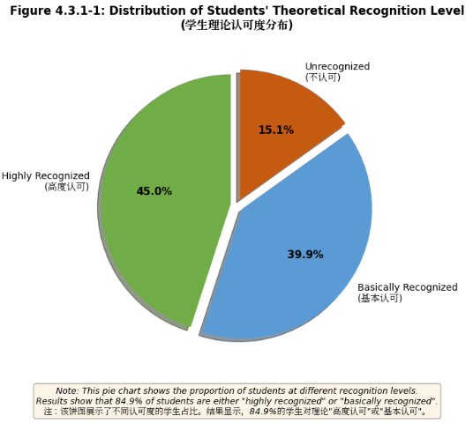
Figure 1 Distribution of Students' Theoretical Recognition Level
Figure 1 note: This pie chart shows the proportion of students at different recognition levels. 45.0% highly recognized, 39.9% basically recognized, 15.1% unrecognized.
Figure 1 shows 84.9% of students "highly recognized" (45.0%) or "basically recognized" (39.9%) the "Growing Circle" theory. Grade differences in students’ cognition and participation willingness further reflect the necessity of hierarchical teaching (Figure 2). Freshmen had the highest theoretical cognition (M=4.12), while sophomores showed the strongest participation willingness (M=3.72).

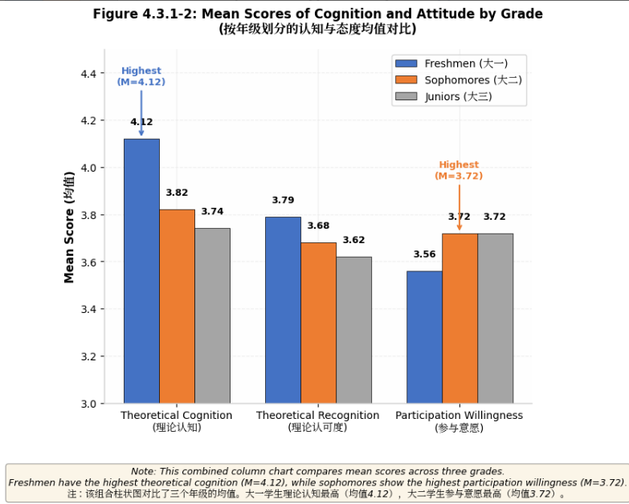
Figure 2 Mean Scores of Cognition and Attitude by Grade
Figure 2 note: This combined column chart compares mean scores of theoretical cognition, recognition, and participation willingness across grades.
Application Effect of the "Growing Circle" Theory
Quantitative Results
The framework’s overall effectiveness was moderate-to-high, with aesthetic inclusiveness (M=3.65) leading, followed by learning mentality (M=3.78) and professional creation ability (M=3.71). Among aesthetic inclusiveness sub-dimensions, diversified aesthetic cognition scored highest (M=3.72), while audience aesthetic adaptation was lowest (M=3.59) (Figure 3).Significant differences were found across professional foundations: students with excellent foundations showed the highest improvement (M=0.95), followed by medium (M=0.72) and weak (M=0.65) (Figure 4). Independent samples t-tests confirmed experimental group post-test scores (resilience: 3.98±0.45; aesthetic inclusiveness: 3.85±0.41; professional creativity: 3.82±0.48) were significantly higher than the control group (p<.001) (Table 1).

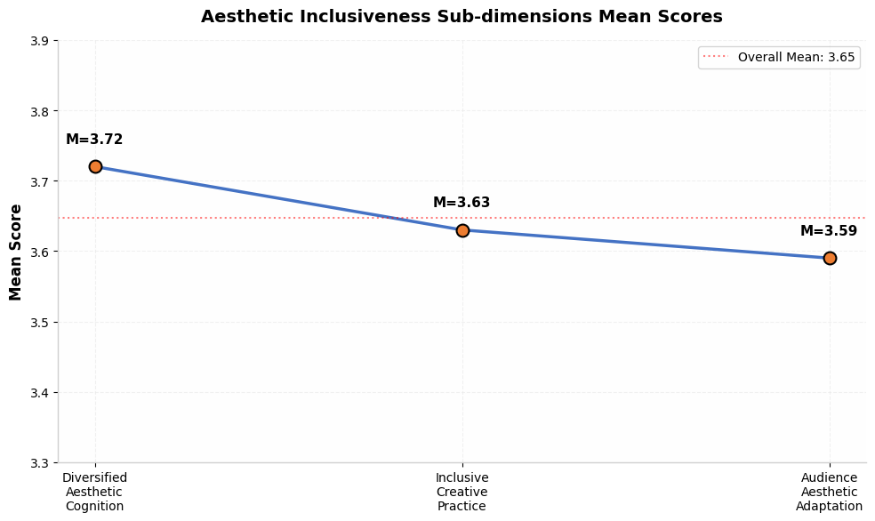
Figure 3 Sub-dimensions of Aesthetic Inclusiveness
Figure 3 note: This line chart shows mean scores of three sub-dimensions: diversified aesthetic cognition, inclusive creative practice, audience aesthetic adaptation.
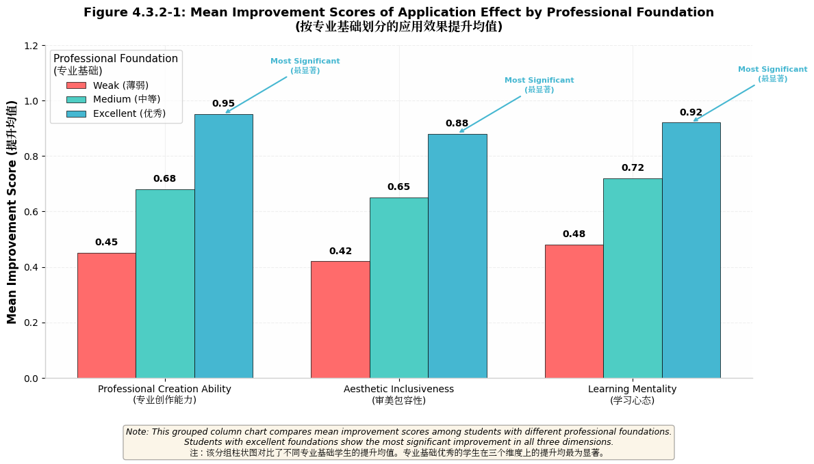
Figure 4 Mean Improvement Scores of Application Effect by Professional Foundation
Figure 4 note: This grouped column chart compares improvement scores across professional foundation levels, with students with excellent foundations showing the most significant improvement (M=0.95).

Variables | Experimental Group  (n=43) | Control Group  (n=43) | t-value | p-value
Resilience | 3.98 ± 0.45 | 3.22 ± 0.58 | 7.02 | < 0.001
Aesthetic Inclusiveness | 3.85 ± 0.41 | 3.10 ± 0.52 | 7.45 | < 0.001
Professional Creativity | 3.82 ± 0.48 | 3.15 ± 0.55 | 6.58 | < 0.001
Table 1 Comparison of Post-test Scores Between Experimental and Control Groups (M±SD)
Qualitative Results (The Missing Piece Practical Training)
78.3% of students integrated "imperfect elements" into creative works (posters, illustrations, storyboards). Four typical storyboard sets interpreted "imperfect growth" from perspectives of choice, mutual reflection, persistence, and the cost of perfection. Quality distribution showed 29.8% excellent, 48.5% good, 18.6% qualified, and 3.1% unqualified works (Figure 5). Teacher evaluation averaged 7.9/10, with 71.2% of students highly recognizing the training (Table 2).
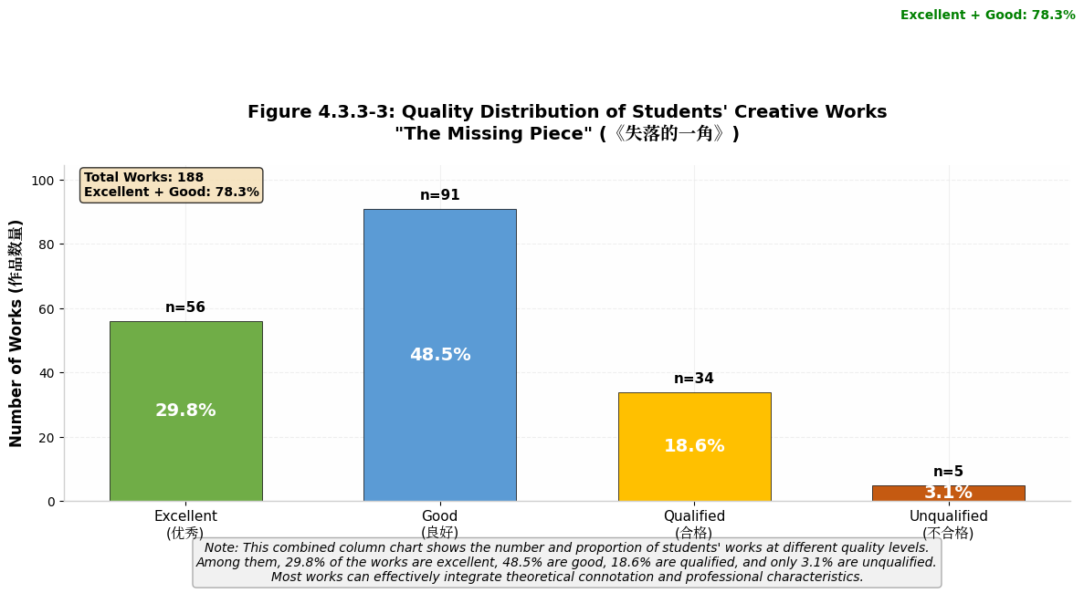
Figure 5 Quality Distribution of Students' Creative Works
Figure 5 note: This combined column chart shows the number and proportion of works at different quality levels.

Aspect | Freshmen | Sophomores | Juniors | Overall
Highly Recognized (%) | 62.2 | 78.6 | 72.8 | 71.2
Basically Recognized (%) | 29.7 | 18.6 | 22.2 | 23.4
Unrecognized (%) | 8.1 | 2.8 | 5.0 | 5.4
Teacher Evaluation (10) | 7.2 | 8.5 | 8.1 | 7.9
Table 2 Evaluation of The Missing Piece Practical Training
Existing Problems and Constraints
1)Theory-Practice Disconnection: 37.2% of students reported abstract theoretical teaching; 21.7% failed to integrate "imperfect growth" connotation into works.
2)Lack of Targeted Teaching: Freshmen (high theoretical cognition, weak practice) and juniors (rich practice, low theoretical cognition) showed unbalanced development.
3)Inadequate Evaluation System: Final works accounted for 70% of evaluation, neglecting process-oriented indicators.
4)Insufficient Support System: 63.5% of students cited lack of creative display platforms; 62.3% of teachers lacked industry practical experience.

DISCUSSION AND CONCLUSION
Research Findings
The "Growing Circle" theory-based practical framework effectively improves Advertising Art Design students’ resilience, aesthetic inclusiveness, and professional creation ability, with significant differences across professional foundations, grades, and genders. This aligns with the core logic of the "Growing Circle" theory (imperfection promotes growth) and Perception Theory (cognitive transformation drives creative behavior) (Goleman, 2019). Compared with domestic research (Li, 2024), this study visualizes abstract theory through practical training, enhancing operability; unlike foreign general education studies (Silverstein, 1976), it combines vocational professional characteristics, filling the research gap.
Optimization Strategies
Curriculum and Teaching Design
1)Hierarchical Teaching Implementation: Design differentiated modules for freshmen (theoretical cognition + basic practice), sophomores (creative trial and error + skill improvement), and juniors (industry project application + reflective optimization).
2)Theory-Practice Integration: Embed "imperfect aesthetic" application into core courses (advertising creative design, visual communication) with specific tasks (e.g., "imperfect element poster creation").
Resource and Support Enhancement
1)Platform Construction: Establish creative display platforms (e.g., "Growing Circle" works exhibition) and industry cooperation bases for real project practice.
2)Teacher Development: Provide training on the "Growing Circle" theory and industry trends, encouraging participation in professional projects.
Evaluation System Improvement
Implement a multi-dimensional evaluation system (process: 50%, final work: 50%) including theoretical understanding, trial-and-error records, and work optimization trajectory.
Limitations and Future Research
This study was conducted in a single vocational college, limiting result generalizability. Future research could expand to multi-regional samples and extend the research cycle to track long-term career development impacts. Additionally, integrating emerging technologies (AI design tools) into the practical framework could enhance its adaptability to industry changes.

REFERENCE
Bennett, E. (2025). Mixed methods research in aesthetic education: Practical guidelines for vocational college studies. Journal of Educational Research and Practice, 41(2), 56–71.
Chen, L., et al. (2025). Application of “Growing Circle” theory in vocational art education. Vocational and Technical Education, 46(5), 68–73.
Drucker, P. (2021). The practice of management. HarperCollins Publishers.
Goleman, D. (2019). Emotional intelligence. Bantam Books.
Jones, J. (2021). Industry demand-oriented aesthetic education optimization for advertising design majors. Journal of Vocational Education, 38(2), 34–42.
Li, J., & Wang, Y. (2025). Longitudinal study on the impact of aesthetic education on vocational college students’ psychological resilience. China Journal of Education, 12, 45–51.
Maslow, A. (2018). Motivation and personality. HarperCollins Publishers.
Ministry of Education of China. (2025). Guidelines for strengthening aesthetic education in vocational colleges (Ministry of Education Official Document [2025] No. 18).
Oliver, R. (2019). Satisfaction: A behavioral perspective on the consumer. Routledge.
Silverstein, S. (1976). The missing piece. HarperCollins Publishers.
Smith, J. (2025). Growing Circle theory in basic art education. International Journal of Art Education, 42(3), 31–40.
Yang, J. (2025). Dynamic evaluation of aesthetic education satisfaction in art majors. Art Education Research, 32(7), 7–10.
Zhang, H. (2025). Current status and reform paths of aesthetic education in vocational advertising art design majors. Vocational Education Research, 18(3), 56–62.
Zhang, L. (2025). Four-stage teaching model based on Growing Circle theory. Journal of Art Education, 28(4), 23–28.
Zhao, H., & Wang, B. (2025). Student satisfaction in vocational aesthetic education. Journal of Guizhou Urban Vocational College, 13(2), 5–8.

Integrating Green Space Design and Artistic Intervention to Promote Well-Being in Contemporary Urban Environments
Thanyarat Apipatrugikorn¹
Pinichbootr@gmail.com
King Mongkut's Institute of Technology Ladkrabang
Abstract
This article examines the integration of green space design and artistic intervention as an innovative approach to promote well-being in contemporary urban environments. The study draws on documentary analysis and conceptual synthesis across the fields of landscape architecture, environmental design, art and design innovation, and well-being studies. Contemporary research has consistently shown that urban green spaces contribute positively to physical and mental well-being by supporting stress reduction, encouraging physical activity, strengthening social cohesion, and mitigating exposure to excessive urban heat. In parallel, public art and creative spatial design have increasingly been recognized as important mechanisms for enriching place identity, emotional engagement, and meaningful interaction between people and their environments.
The convergence of landscape architecture, environmental design, and artistic practice can generate green space design that functions not only as ecological infrastructure but also as cultural and therapeutic public spaces. Such spaces may take the form of art gardens, learning gardens, creative parks, or green corridors enriched with sculptures, interactive installations, murals, sensory elements, and community-based art activities. These design strategies can enhance users' aesthetic experience, deepen emotional attachment to place, and improve the inclusiveness and vitality of urban public space. In this sense, art is not treated merely as decoration, but as an active design element that mediates perception, stimulates participation, and expands the restorative potential of green environments. The findings reveal three major outcomes: green spaces contribute directly to physical and psychological well-being; artistic intervention enhances emotional, aesthetic, and social experience in public space; and the integration of both elements generates an innovative design framework for well-being-oriented urban development. This interdisciplinary framework reflects the direction of innovation in art and design by linking environmental functionality with creative expression, social value, and human-centered experience. Therefore, the integration of art into urban green space design offers a significant conceptual and practical model for developing healthier, more resilient, and culturally meaningful cities in the future.
Keywords: Green space design, Public art, Urban well-being, Creative landscape, art and design innovation

Introduction
Rapid urbanization has significantly transformed the physical and social character of cities, often resulting in reduced access to nature, increased environmental stress, and declining opportunities for restorative public life. In many urban contexts, dense built environments, heat accumulation, air pollution, and limited communal spaces have contributed to growing concerns about physical and mental well-being (World Health Organization, 2016). Within this context, urban green spaces have emerged as a critical component of healthy city development because they support physical activity, reduce stress, improve perceived well-being, and generate important environmental co-benefits such as heat mitigation and ecological resilience. Recent public health and urban studies literature has consistently affirmed that green and blue infrastructure can contribute not only to healthier urban living, but also to greater social equity and long-term urban sustainability (Hunter et al., 2023).
At the same time, contemporary art and design disciplines have increasingly expanded beyond object-making toward forms of spatial, participatory, and socially engaged practice. Public art is no longer understood solely as an ornamental addition to build environments; rather, it is recognized as a placemaking strategy that can shape identity, stimulate interaction, strengthen emotional attachment to place, and foster inclusive civic experiences (Matthews & Gadaloff, 2022). Studies on public art and urban renewal suggest that artistic intervention can enhance the experiential quality of public space, reinforce community meaning, and contribute to more vibrant and culturally legible urban environments. This shift is especially relevant to art and design innovation, where creative practice is expected to respond to complex societal challenges through interdisciplinary and human-centered approaches.
The intersection of these two domains green space design and artistic intervention therefore offers a particularly promising framework for rethinking urban well-being. When landscape architecture, environmental planning, and artistic practice are intentionally integrated, public space can evolve from a merely functional or decorative environment into a multisensory, restorative, and socially meaningful setting. Such spaces may appear as art gardens, learning gardens, therapeutic parks, sculpture-integrated landscapes, or green corridors enriched with interactive installations, murals, sound elements, and community art processes. In these contexts, art performs an active role in mediating perception, encouraging engagement, and expanding the emotional and cultural value of urban nature. Simultaneously, the green dimension enhances comfort, restoration, and environmental performance, including support for urban heat adaptation.
Despite growing recognition of the separate benefits of green infrastructure and public art, scholarly discussion on their integrated application remains comparatively limited, particularly in relation to well-being-oriented design frameworks. Much of the existing research addresses urban greenery through environmental health perspectives, while art is frequently discussed through cultural policy, placemaking, or regeneration. There remains a need for a more explicitly interdisciplinary perspective that situates artistic intervention within the design of green public environments as a mechanism for promoting holistic well-being. This perspective is especially valuable for the fields of art and design, where innovation increasingly involves the synthesis of aesthetic experience, social participation, ecological awareness, and spatial functionality.
Accordingly, this article proposes that the design of green spaces integrated with artistic elements should be understood as an innovative approach for contemporary urban development. By linking environmental performance with aesthetic engagement and community experience, such spaces can respond to present-day urban challenges in ways that are ecologically sensitive, culturally meaningful, and supportive of public health. The study therefore aims to examine how the integration of art and green space design can contribute to well-being promotion, while also advancing the discourse of innovation in art, landscape, and environmental design.

Objective
1. To examine the concept of integrating green space design with artistic elements in order to promote well-being in urban environments.
2. To investigate how artistic intervention can enhance the aesthetic, emotional, and social values of green public spaces.
3. To propose a design framework that links art, landscape, and environmental planning for the development of innovative green spaces that support human well-being.
Literature Review
1. Urban Green Space and Well-Being
Urban green space has become an important topic in contemporary research on healthy cities, environmental planning, and public well-being. Existing literature consistently indicates that access to urban green spaces is associated with multiple benefits, including reduced stress, improved mental well-being, support for physical activity, and stronger opportunities for social interaction (World Health Organization Regional Office for Europe, 2017). The World Health Organization has emphasized that urban green space interventions can contribute positively to public health, particularly in relation to mental well-being, social well-being, and environmental quality. Likewise, recent scholarship in public health has highlighted that green and blue spaces can play a substantial role in reducing health inequities and improving urban quality of life (Hunter et al., 2023).

In addition to mental and social benefits, green infrastructure also contributes to environmental comfort and climate responsiveness in cities. Studies on urban overheating and green-blue infrastructure suggest that vegetation, parks, green corridors, wetlands, and other ecological design strategies can mitigate excessive urban heat and improve thermal comfort (Kumar et al., 2024). This environmental function is especially significant in dense urban areas where the urban heat island effect has intensified the risks associated with climate change. Therefore, green space is not only valuable as a visual or recreational amenity, but also as a form of ecological infrastructure that directly supports healthier and more resilient urban living.

Recent reviews further suggest that the quality, accessibility, and design characteristics of green space influence the extent of these well-being outcomes. It is not simply the presence of greenery that matters, but also how such spaces are designed, experienced, and maintained. Improvements to urban green spaces can shape how users perceive restoration, comfort, safety, and belonging. This indicates that design intervention is a critical factor in transforming green areas into places that genuinely support human well-being.

2. Public Art, Placemaking, and the Experience of Urban Space
In parallel with the growing importance of urban green infrastructure, public art has emerged as a major element in placemaking and the cultural activation of public environments. Contemporary studies increasingly frame public art not as a decorative supplement, but as a strategic component of urban development that can influence place identity, civic participation, and users' emotional engagement with space (Matthews & Gadaloff, 2022). Research on public art and placemaking indicates that artistic interventions can improve the perceived quality of public space, strengthen local meaning, and generate social and cultural value within everyday urban environments.

The placemaking literature also suggests that arts-based interventions can encourage community interaction and reinforce social cohesion. Creative placemaking, in particular, is often associated with collaborative processes that connect cultural expression, spatial transformation, and local participation. Through murals, sculptures, installations, performances, and interactive artworks, public space can become more legible, memorable, and inclusive. In this context, art serves as a medium through which urban users encounter place not only functionally, but also emotionally and symbolically.

Furthermore, emerging evidence suggests that artistic experience itself may have implications for well-being. Although the literature in this area is still developing, studies have begun to examine how visual and urban art can support affective response, attention, reflection, and restorative perception. This opens an important avenue for art and design research, because it positions artistic intervention as part of the experiential and therapeutic potential of the urban environment.

3. The Intersection of Green Space and Artistic Intervention
research on green space and research on public art have each developed substantially, studies that directly integrate these two dimensions remain relatively limited. Most environmental health literature concentrates on ecological function, physical activity, and mental health outcomes, whereas art and design scholarship often emphasizes identity, expression, culture, and placemaking. The intersection between these domains is therefore an emerging interdisciplinary field with strong potential for innovation.

Conceptually, the integration of artistic elements into green space design can be understood as a way of expanding the restorative and participatory capacity of public environments. Green settings already support recovery from stress and attention fatigue, while art can enrich perception, create focal points, generate narrative meaning, and encourage deeper engagement with place. When combined, these elements may produce environments that are not only ecologically beneficial, but also aesthetically stimulating, culturally expressive, and socially inviting. Such environments may include sculpture gardens, community art parks, learning landscapes, therapeutic gardens, and green corridors with integrated artistic components. This synthesis aligns with current thinking in restorative urban environments, which recognizes that multisensory and experiential qualities of public space are essential to urban well-being.

This integrated perspective is particularly relevant to contemporary art and design innovation. In current design discourse, innovation is increasingly defined not only by technological novelty, but also by the ability to respond creatively to social, ecological, and human-centered challenges. Designing green public spaces with artistic intervention reflects this broader meaning of innovation because it combines environmental performance, aesthetic experience, social value, and participatory potential within a single spatial framework. Therefore, the convergence of art, landscape, and well-being offers a significant model for future-oriented design practice and interdisciplinary scholarship.

4. Research Gap
Despite increasing recognition of the separate benefits of urban greenery and public art, there remains a gap in the literature concerning their combined role in promoting holistic well-being. Much of the existing work addresses green spaces in terms of public health and climate adaptation, while art is frequently discussed through placemaking, regeneration, or cultural policy. Fewer studies have proposed an integrated framework that explicitly examines how artistic intervention within green environments can support physical, emotional, social, and environmental well-being simultaneously.

This gap creates an opportunity for further inquiry in art and design research, especially in urban and community-based contexts. A clearer interdisciplinary framework is needed to explain how artistic strategies can be embedded in green space design not merely as decoration, but as active components that shape perception, participation, and restorative experience. Such a framework would contribute to the development of innovative public environments that are ecologically responsive, culturally meaningful, and beneficial to human well-being.

Research Methodology
This study employed a qualitative research approach with an emphasis on documentary analysis and conceptual synthesis in order to examine the integration of green space design and artistic intervention for the promotion of well-being in urban environments. The methodology was designed to explore interdisciplinary knowledge across the fields of art and design, landscape architecture, environmental planning, public space studies, and well-being research.

Research Design
The study was structured as a qualitative academic inquiry aimed at analyzing theoretical perspectives, related studies, and design concepts concerning the relationship between green spaces, public art, and human well-being. It focused on synthesizing knowledge from multiple disciplines including art, design, landscape architecture, environmental planning, and environmental psychology to propose a conceptual framework for innovative green space design that incorporates artistic elements.

Data Collection
Data were collected through secondary sources, including academic books, peer-reviewed journal articles, policy reports, and research publications relevant to the following themes:

1. Concepts of urban green space and environmental design,
2. Theories of well-being in relation to public space,
3. Public art, place making, and spatial experience, and
4. Interdisciplinary approaches in art and design innovation that is, collaborative processes in which art, landscape architecture, and environmental design work together across disciplinary boundaries to generate creative and socially responsive solutions.

The literature selected for review was chosen based on its relevance to the study objectives, conceptual significance, and contribution to understanding the intersections among art, green infrastructure, and well-being.

Data Analysis

The collected data were analyzed using content analysis and thematic analysis. In content analysis, the researcher systematically reviewed and categorized key concepts, arguments, and findings from the selected academic literature. In thematic analysis, recurring patterns and interpretive themes were identified, grouped, and synthesized across the body of literature reviewed. The analysis focused on identifying major themes, including:

1. The role of green spaces in promoting physical and mental well-being,
2. The function of art in shaping public experience and place identity,
3. The integration of landscape and artistic design in urban environments, and
4. The potential of interdisciplinary design to generate innovative and meaningful public spaces.

The results of the thematic analysis are summarized in Table 1 below, which maps the primary themes identified from the literature review to their corresponding sources and design implications.

Table 1: Summary of Thematic Analysis Key Themes and Design Implications

Theme | Key Concepts | Representative Sources | Design Implication
Green Space and  Well-Being | Stress reduction, physical activity, thermal comfort | WHO (2016, 2017); Hunter et al. (2023); Kumar et al. (2024) | Design green spaces for health and ecological function
Public Art and Placemaking | Place identity, social cohesion, emotional engagement | Matthews & Gadaloff (2022) | Embed art as an active spatial component, not decoration
Integration of Art and Green Space | Restorative environments, multisensory experience, cultural expression | Literature synthesis | Develop art-integrated green spaces as innovative urban design
Interdisciplinary Innovation | Cross-field synthesis, human-centered design, environmental responsiveness | Art and design discourse | Adopt interdisciplinary frameworks for urban well-being

These themes were then synthesized to develop an analytical understanding of how artistic intervention may enhance the restorative, social, and cultural value of green spaces, and to inform the design framework presented in the Research Results section.
Scope of the Study
This study focused on the conceptual relationship between green space design, artistic intervention, and well-being promotion in urban public environments. The scope was limited to academic and theoretical discussions related to landscape, public art, environmental design, and community-oriented space design. The study did not include fieldwork, experimental measurement, or direct user surveys.
Research Outcome
The outcome of this study is a conceptual framework that explains how the integration of artistic elements into green public spaces can function as an innovative design approach to support well-being. The findings are expected to contribute to the discourse in art and design by demonstrating that green spaces enriched with artistic components can serve ecological, cultural, emotional, and social purposes simultaneously.
Research Results
The findings of this study reveal that the integration of green space design with artistic intervention offers significant potential for promoting well-being in urban environments. Based on the analysis of relevant literature and conceptual synthesis across the fields of art and design, landscape architecture, environmental planning, and well-being studies, the results can be summarized into three major dimensions.
1. Green spaces contribute directly to physical and psychological well-being
The analysis indicates that green spaces play an important role in improving urban well-being by supporting both physical and mental health. In physical terms, green public spaces encourage walking, relaxation, and outdoor activity, while also improving environmental comfort through shading, cooling effects, and mitigation of urban heat. In psychological terms, green environments contribute to stress reduction, emotional recovery, mental calmness, and improved quality of life. These findings suggest that green space should be understood not only as an environmental resource, but also as a restorative public setting that supports healthier urban living.
2. Artistic intervention enhances emotional, aesthetic, and social experience in public space
The results further show that artistic elements integrated into public green spaces can significantly enrich users' experiences. Art contributes to the environment by creating visual identity, aesthetic value, symbolic meaning, and emotional attachment to place. Sculptures, murals, creative installations, interactive artworks, and community-based artistic features help transform ordinary green spaces into more engaging and memorable environments. In addition, artistic intervention encourages social interaction, cultural participation, and a stronger sense of belonging among users. Therefore, art functions not merely as decoration, but as an active design component that shapes perception and experience within public space.
3. The integration of art and green space generates a design framework for well-being-oriented design
The most significant result of this study is the identification of an interdisciplinary design framework in which green infrastructure and artistic practice work together to produce more meaningful public environments. The combination of ecological function and artistic expression creates spaces that are restorative, inclusive, culturally expressive, and socially active. This finding supports the idea that innovative art and design should not be limited to formal or visual experimentation alone, but should also address human well-being, environmental responsiveness, and community engagement. In this respect, art gardens, learning parks, therapeutic landscapes, and green corridors with integrated artistic elements represent practical models of contemporary design innovation.

Discussion
The findings of this study affirm that the integration of green space design with artistic intervention offers a meaningful and interdisciplinary approach to promoting well-being in urban environments. This result is consistent with existing evidence showing that urban green spaces are associated with improved mental well-being, support for physical activity, reduced stress, and broader public-health benefits (Hunter et al., 2023). Recent reviews also emphasize that green and blue spaces can contribute to healthier cities while helping address social inequities and environmental pressures. In this sense, the present study supports the view that green space should be understood not merely as an environmental amenity, but as a health-supportive urban infrastructure.
A key implication of the results is that the value of green space depends not only on its presence, but also on the quality of its design and the character of users' experience within it. The study suggests that when artistic elements are integrated into green environments, such spaces become more than passive landscapes; they become emotionally legible, aesthetically engaging, and socially inviting settings. This interpretation aligns with scholarship on public art and placemaking (Matthews & Gadaloff, 2022), which argues that artistic interventions can strengthen place identity, enrich everyday urban experience, and support civic meaning. Public art, therefore, should not be regarded as a secondary decorative layer, but as an active spatial medium that shapes perception, interaction, and attachment to place.
The results also indicate that art can expand the restorative capacity of green environments. Green spaces are often discussed in relation to recovery from stress and sensory relief, while art introduces symbolism, narrative, multisensory stimulation, and interpretive depth. When these two components are combined, the urban environment may offer a more holistic form of restoration that includes environmental comfort, emotional resonance, and cultural meaning. This point is important because recent literature increasingly frames well-being in cities as a multidimensional condition shaped by ecological, spatial, social, and psychological factors rather than by environmental exposure alone. The study therefore suggests that art-integrated green spaces may function as restorative environments in a richer and more human-centered way than conventional green infrastructure alone.
Another important dimension concerns climate responsiveness and environmental resilience. The discussion of green space in this study is not limited to visual or therapeutic qualities; it also includes the capacity of vegetation and green infrastructure to mitigate urban heat and improve thermal comfort. This is particularly relevant in contemporary cities facing rising temperatures and the intensification of urban heat island effects (Kumar et al., 2024). Current review research confirms that green infrastructure can be an effective cooling strategy, especially when it is designed deliberately and connected across urban systems. From this perspective, integrating artistic intervention into green corridors, parks, and public landscapes may create spaces that are simultaneously climate-adaptive, culturally expressive, and socially beneficial.

From the standpoint of art and design innovation, the findings reinforce the idea that innovation should not be defined only by new forms, technologies, or visual novelty. In contemporary design discourse, innovation increasingly refers to the ability to respond creatively to complex human and environmental challenges. The integration of art, landscape, and well-being exemplifies this broader model of innovation because it combines aesthetic expression, social participation, ecological performance, and user-centered experience within one spatial framework. In this regard, art gardens, learning parks, therapeutic landscapes, and green corridors with embedded artistic elements can be interpreted as design innovations that operate across environmental, cultural, and public-health dimensions at the same time.
The study also highlights an important research gap. Although there is strong evidence for the benefits of green space and growing recognition of the placemaking role of public art, these domains are still often discussed separately in academic literature. Environmental health research tends to emphasize measurable outcomes such as stress reduction, activity levels, and heat mitigation, whereas art and design studies frequently emphasize symbolism, participation, and identity. The present study argues that a more integrated framework is needed — one that explains how artistic strategies embedded in green environments can jointly support physical, emotional, social, and environmental well-being. This interdisciplinary perspective is especially valuable for future scholarship in art, design, landscape studies, and community-based urban development.
In summary, the discussion confirms that the relationship between green space and artistic intervention is mutually reinforcing. Green environments provide the ecological and restorative foundation, while art intensifies experiential quality, meaning, and participation. Together, they create public spaces that are healthier, more inclusive, and more culturally significant. Therefore, the integration of green design and artistic practice should be considered a promising model for future urban development and for advancing the discourse of innovation in art and design.
Suggestions
Suggestions for Design Practice
Designers, landscape architects, and artists should consider integrating artistic elements into green public spaces in a more intentional and user-centered manner. Art should not be applied merely as decoration, but as a meaningful spatial component that enhances emotional engagement, aesthetic experience, and social interaction. The design of such spaces should also respond to the local context, community identity, and environmental conditions in order to create public environments that are both functional and culturally meaningful.

Suggestions for Community and Urban Development
Urban planners and local authorities should promote the development of green spaces that combine ecological value with artistic and cultural expression. Public parks, green corridors, learning gardens, and community spaces may be designed to support not only environmental quality, but also social participation, inclusive access, and psychological restoration. Community involvement in the design process should be encouraged so that public spaces reflect local needs and strengthen a sense of ownership and belonging.

Suggestions for Academic Research
Future studies should expand this topic through empirical research methods, such as case studies, field observation, user interviews, surveys, or experimental assessments of well-being outcomes. Comparative studies between conventional green spaces and art-integrated green spaces would also be valuable in demonstrating the distinct contribution of artistic intervention to public well-being. In addition, further interdisciplinary research is recommended to deepen
the theoretical connection among art, landscape, environmental psychology, and urban design.

Suggestions for Art and Design Innovation
The integration of green space and art should be further developed as a model of contemporary design innovation. Future creative projects may explore interactive installations, sensory design, therapeutic landscapes, and participatory art practices as part of sustainable urban development. This approach can broaden the role of art and design from visual production to social, environmental, and well-being-oriented innovation.

References

Hunter, R. F., Nieuwenhuijsen, M., Fabian, C., Murphy, N., O’Hara, K., Rappe, E., Sallis, J. F., Lambert, E. V., Sarmiento, O. L., Sugiyama, T., & Kahlmeier, S. (2023). Advancing urban green and blue space contributions to public health. The Lancet Public Health, 8(9), e735–e742. https://doi.org/10.1016/S2468-2667(23)00156-1
Kumar, P., Debele, S. E., Khalili, S., Halios, C. H., Sahani, J., Aghamohammadi, N., de Fatima Andrade, M., Athanassiadou, M., Bhui, K., Calvillo, N., Cao, S.-J., Coulon, F., Edmondson, J. L., Fletcher, D., Dias de Freitas, E., Guo, H., Hort, M. C., Katti, M., Kjeldsen, T. R., Lehmann, S., Rogers, C. D. F., Runming, Y., Wang, F., Wenk, J., & Jones, L. (2024). Urban heat mitigation by green and blue infrastructure: Drivers, effectiveness, and future needs. The Innovation, 5(2), Article 100588. https://doi.org/10.1016/j.xinn.2024.100588
Matthews, T., & Gadaloff, S. (2022). Public art for placemaking and urban renewal: Insights from three regional Australian cities. Cities, 127, Article 103747. https://doi.org/10.1016/j.cities.2022.103747
World Health Organization. (2016). Urban green spaces and health. WHO Regional Office for Europe.
World Health Organization Regional Office for Europe. (2017). Urban green space interventions and health: A review of impacts and effectiveness. WHO Regional Office for Europe.

TRANSFORMATION OF CONTEMPORARY CHINESE TRADITIONAL LUNAR FLOWER PATTERNS IN THE DESIGN
OF LACQUER EARRINGS FOR YOUNG
AND MIDDLE-AGED CONSUMERS
Yanxian Fan¹
¹Academy of Arts and Philosophy, Shinawatra University
fanyanxian2024@163.com¹
Abstract
This study investigates the contemporary transformation of traditional Chinese lunar floral patterns in lacquer earrings design, with a focus on meeting the aesthetic and cultural preferences of young and middle-aged consumers. Deeply rooted in China’s traditional calendrical culture, lunar floral motifs embody rich symbolic meanings and aesthetic values. This research aims to explore how these traditional patterns can be reinterpreted and integrated into contemporary lacquer earrings design to respond to modern design sensibilities and cultural consumption trends. A qualitative research methodology is adopted, including literature review, visual culture analysis, and practice-based design research. The study emphasizes the interpretation of symbolic meanings embedded in traditional lunar floral patterns, alongside material exploration and experimental ear pendant design practice.
The findings demonstrate that through formal abstraction, material innovation, and contemporary design strategies, traditional lunar floral patterns can be effectively transformed into lacquer earrings designs that preserve cultural identity while appealing to contemporary consumers. The research confirms the feasibility and cultural significance of applying traditional Chinese lunar motifs within modern lacquer earrings design. Furthermore, it highlights the value of integrating traditional cultural symbolism with modern design thinking and material experimentation, and demonstrates that practice-based design research can serve as an effective bridge between traditional culture and contemporary jewelry design. This study contributes to the sustainable development and contemporary dissemination of traditional Chinese ear pendant design.
Keywords: Chinese lunar floral patterns, Lacquer earrings design, Contemporary design transformation, Cultural heritage innovation, Young and Middle-Aged Consumers.
Introduction
Traditional Chinese lunar culture represents a highly structured temporal system that extends beyond calendrical measurement to encompass philosophical thought, social order, and aesthetic perception. Since the seasonal prescriptions documented in the Book of Rites (Liji · Yueling), the Chinese worldview has conceptualized time as an organic process shaped by the dynamic relationship between humans and nature. This perspective reflects the philosophical principle of the unity of heaven and humankind, emphasizing balance, cyclical transformation, and ecological harmony(Ying, 2018).
Within this cultural framework, floral motifs function as a symbolic medium through which seasonal change is visually articulated. Each flower is associated with a specific lunar month and conveys culturally embedded meanings: the plum blossom signifies resilience, the peony represents prosperity, and the lotus embodies moral purity. Rather than serving merely decorative purposes, these motifs operate as carriers of collective memory and cultural identity.
Historically, lunar floral imagery evolved into a coherent visual language widely applied across traditional crafts, including ceramics, textile arts, metalwork, and lacquerware. Particularly during the Ming and Qing dynasties, floral ornamentation became a defining feature of artistic production. However, processes of modernization and industrialization have increasingly distanced such symbolic systems from contemporary daily life. As a result, traditional floral culture now faces the risk of semantic erosion, wherein motifs survive as stylistic references while their cultural depth gradually diminishes.
Simultaneously, globalization has intensified concerns regarding cultural homogenization, prompting renewed scholarly and creative interest in heritage revitalization. In design disciplines, this has generated an ongoing tension between cultural preservation and contemporary innovation. Designers are challenged not only to maintain recognizable cultural characteristics but also to respond to evolving aesthetic expectations and modes of consumption(Guo et al, 2025).
Recent studies suggest that younger generations of consumers increasingly value culturally meaningful products that support identity construction while aligning with modern lifestyles. The growing popularity of the “New Chinese Style” reflects a broader shift away from superficial historicism toward interpretive transformation—one that extracts essential cultural logic rather than replicating traditional forms. This transition signals an important opportunity for design to act as a mediator between historical continuity and contemporary relevance.
Among traditional materials, lacquer holds particular significance due to its technical sophistication and cultural resonance. Its tactile warmth, chromatic depth, and capacity to develop a patina over time embody a sense of material vitality closely aligned with the temporality embedded in lunar culture. When applied to jewelry objects intimately connected to bodily presence and self-expression—lacquer offers a compelling platform for translating cultural symbolism into wearable artifacts(Xiao et al, 2024). Contemporary jewelry has increasingly moved beyond ornamentation to function as a narrative device through which personal and cultural identities are negotiated.
Despite growing academic attention to cultural heritage innovation, existing scholarship has largely focused on historical analysis or preservation strategies, with comparatively limited exploration of systematic design methodologies for transforming traditional symbolic resources into contemporary artifacts. In particular, the application of lunar floral motifs within modern lacquer earrings remains underexamined. This gap highlights the need for research that integrates cultural interpretation, material experimentation, and design practice within a coherent methodological framework.
To address this gap, the present study adopts a practice-based research approach to investigate how traditional Chinese lunar floral patterns can be reinterpreted through contemporary design strategies. Specifically, the research seeks to decode the cultural semantics of these motifs, translate their visual structures into modern design language, and validate the feasibility of this transformation through lacquer earrings practice.
The study contributes to design research in three principal ways. First, it proposes a cultural semantic framework that supports the systematic reinterpretation of traditional motifs. Second, it develops an integrative “culture–design–user” model that bridges theoretical analysis and creative production. Third, it demonstrates how practice-based inquiry can function as a form of knowledge generation, enabling designers to engage critically with heritage while producing culturally distinctive outcomes.
By positioning design as an interpretive act rather than a process of stylistic reproduction, this research reframes traditional culture as a dynamic resource for innovation. In doing so, it supports broader discussions on cultural sustainability and offers methodological insights for designers seeking to navigate the intersection of heritage and contemporary creative practice.

Objective
The objectives of this research are threefold:
- to analyze the cultural semantics and visual structures of traditional Chinese lunar floral patterns;
- to develop a systematic design methodology that supports the contemporary transformation of these motifs; and
- to validate the feasibility of this methodology through practice-based lacquer earrings design.

Literature Review

1. Research on Lunar Floral Motifs
Scholarly inquiry into lunar floral motifs has accumulated substantial knowledge both domestically and internationally; however, the majority of studies remain situated within historical and cultural analysis. argues that Chinese floral patterns are characterized by pronounced symbolic attributes and semantic depth, functioning not merely as decorative forms but as a visual language embedded with cultural meaning(Ruan, 2023). Their symbolic system demonstrates relative stability while reflecting anthropomorphic ethics, social hierarchy, and broader cultural values.
From the perspective of visual language, researchers generally agree that traditional Chinese floral motifs exhibit distinctive structural characteristics. These include the construction of rhythmic harmony through curvilinear forms, an emphasis on linear organization and compositional cadence, and the frequent use of symmetrical, radial, or continuous arrangements. Moreover, such motifs prioritize stylization and abstract imagery, embodying what has been described as “symbolic abstraction” rather than naturalistic representation. further proposes that traditional Chinese ornamentation reflects an aesthetic paradigm of symbolic abstraction, in which visual form is less concerned with realism than with communicating cultural energy and maintaining symbolic continuity.
Despite these insights, existing scholarship has predominantly focused on two-dimensional or large-scale media such as painting, architecture, and textiles. Comparatively little attention has been given to jewelry, a small-scale medium that interacts dynamically with the human body. The challenge of preserving cultural recognizability within limited spatial dimensions while simultaneously achieving contemporary aesthetic translation remains insufficiently explored. Addressing this issue constitutes a central concern of the present study(Subedi & Hamal, 2023).
2. Developments in Lacquer Art and Contemporary Jewelry Design
Lacquer art, one of China’s most representative traditional crafts, embodies over eight millennia of technical evolution and cultural accumulation. observes that the stratification, temporality, and luminosity of natural lacquer render it a material capable of “recording time.” The repetitive processes of coating and polishing effectively layer temporal traces onto the object, while chromatic transformation and phenomena such as lacquer cracking impart a sense of material vitality(Xiao等, 2024b). This notion of lacquer as a “living material” forms a philosophical parallel with the cyclical understanding of time embedded within lunar culture.
Research in contemporary jewelry design indicates an ongoing expansion beyond conventional boundaries of material, form, and function. Increasingly, designers emphasize innovative applications, interdisciplinary integration, personalized expression, and sustainability. Modern consumers no longer evaluate jewelry solely in terms of material rarity but also consider the cultural meanings, artistic value, and emotional connections it conveys (Lucas & Chapin, 2015). This shift creates favorable conditions for incorporating traditional cultural elements into contemporary design practice.
Nevertheless, while both lacquer craftsmanship and jewelry design have been extensively studied, their intersection particularly as a vehicle for cultural reinterpretation remains underdeveloped within academic discourse.
3. Research Gaps and Opportunities for Innovation
A systematic review of the literature reveals several critical gaps that frame the necessity of this research.
First, there is a lack of methodological coherence in studies addressing media transformation. Existing research tends either to treat lunar culture as a purely theoretical subject or to examine lacquer techniques as an independent craft tradition. Few studies have systematically explored their integration through the specific medium of lacquer ear ornaments. This fragmentation limits a comprehensive understanding of how cultural symbols and craft practices can converge at the micro-design level.
Second, current scholarship demonstrates structural limitations in design methodology. Much of the literature remains confined to macro-level theoretical discussions or isolated technical case analyses, offering limited operational guidance for designers. Three issues are particularly evident: the absence of systematic methods for translating the temporal narratives of lunar culture into design language; the lack of a clearly articulated theoretical framework connecting lacquer materiality with cultural expression; and the disconnect between design practice and user-oriented research, which constrains the effective market transformation of culturally informed products.
Third, practical interdisciplinary integration remains insufficient. Lunar culture, lacquer craftsmanship, and jewelry design originate from distinct disciplinary domains, and existing studies frequently adopt single-perspective approaches without fostering meaningful cross-disciplinary dialogue. Such boundaries result in several consequences: cultural research struggles to translate into tangible design language; technological innovation risks lacking cultural depth; and design practice may become stylistically superficial due to limited theoretical grounding.
Collectively, these gaps not only highlight the necessity of the present study but also delineate a significant space for innovation. By integrating cultural interpretation, material exploration, and practice-based design, this research seeks to contribute a systematic framework for the contemporary transformation of traditional symbolic resources.

Research Methodology

1. Research Design and Methodological Framework
This study adopts a qualitative, practice-based research approach in which design practice functions simultaneously as a mode of inquiry and a form of knowledge production(Yijing & Sharudin, 2023). Within this framework, design is understood not merely as a final outcome but as an investigative process that integrates cultural interpretation, material exploration, and user-oriented evaluation. The research follows an iterative cycle of development, evaluation, reflection, and redesign, allowing insights generated through practice to continuously inform subsequent design decisions.
Six complementary methods were employed. First, a literature review systematically examined scholarship related to lunar culture, floral motifs, and lacquer craftsmanship. Second, cultural semiotic analysis was conducted to interpret the semantic structures embedded in lunar floral symbolism. Third, visual form analysis deconstructed the compositional elements and formal characteristics of traditional patterns. Fourth, expert interviews were carried out with six participants—including lacquer artisans, jewelry designers, and cultural brand practitioners—using semi-structured protocols to capture professional perspectives. Fifth, practice-based design research guided the creation of a lacquer ear ornament series inspired by lunar floral themes. Finally, design critique and reflective evaluation were undertaken through expert feedback and peer review to assess the effectiveness of the proposed design methodology.
The overall research framework follows a progressive structure: cultural foundation → expert cognition → design generation → practice validation → theoretical feedback. Beginning with the cultural semantics of lunar floral motifs, the study integrates expert insights regarding target users to inform design development. The resulting artifacts were evaluated through wearing experiences and peer assessment, enabling the extraction of theoretical implications from practical outcomes. This structure ensures a systematic transformation from cultural resources to design innovation while aligning with the process-oriented and reflective nature of practice-based design research.
2. Cultural Semantic Analysis Framework
Drawing upon (Panofsky, E. 1955) three-tier iconographic theory, this study develops an interpretive framework for analyzing lunar floral motifs. At the symbolic level, the research investigates cultural connotations, temporal philosophy, and ethical values embedded within the patterns. At the referential level, it examines the relationship between the motifs and natural rhythms, agricultural cycles, and folk traditions. At the affective level, the study explores the mechanisms through which these motifs evoke emotional resonance among contemporary consumers. The integration of these dimensions forms a semantic matrix of lunar floral culture, clarifying both the symbolic attributes of the flowers and their potential pathways for design translation(Guangzhou & Porncharoen, 2024).
Visual form analysis combines formal aesthetics with functional considerations relevant to jewelry wearers. Structural organization was examined to decode the compositional logic between primary floral elements and supporting motifs. Stylistic genealogy distinguished among realistic, abstract, and imagistic modes of representation. Rhythmic characteristics such as repetition, symmetry, and radial composition were analyzed for their capacity to reinforce the cyclical imagery inherent in lunar culture.
Color translation focused on the evolution of traditional chromatic symbolism toward contemporary neutral palettes, facilitating broader aesthetic acceptance. Additionally, scale and weight introduced a critical analytical dimension specific to ear ornaments. Based on empirical observations, lightweight construction (single-piece weight below 5 grams) and compact dimensions (diameter ≤ 3 cm) were established as key ergonomic criteria.
3. Design Practice and Transformation Strategies
The design practice employed a three-phase transformation strategy: extraction, deconstruction, and reconstruction. During the extraction phase, essential visual elements were identified from lunar floral motifs. The deconstruction phase disrupted original compositions through geometric reduction and minimalist reinterpretation. Finally, the reconstruction phase creatively integrated these transformed visual elements with lacquer materiality to generate a new design language(Zhao & Sahari, 2025).
The design process also emphasized a balance across three levels of emotional design. The visceral level was addressed through the chromatic system of lacquer and the aesthetic qualities of floral forms. The behavioral level prioritized wearing comfort and versatility in styling. The reflective level engaged the cultural symbolism of lunar traditions, encouraging contemplation of temporality and seasonal transformation. This multi-layered approach ensured that the resulting works achieved equilibrium among visual appeal, functional performance, and cultural depth.
Table 3.1 Transformation Strategy of Contemporary Artistic Patterns in the Design of China Lacquer Ears
Policy type | Specific methods(Combining lunar flower arrangements with lacquer earrings) | Design Effect/Inspiration
cultural convergence strategy | Take the moon flower as the symbol of time culture, extract the spiritual connotation of the flower (such as the plum blossom's high and noble, chrysanthemum's reclusive) to avoid specific replication. | Inheriting the Root of Traditional Culture, Jewelry Becomes a Wearable Time Narrative Carrier
formal translation policy | Abstracting Flower Structure into Linear,Geometric or Imaginative Form and Reconstructing Contemporary Form with Plasticity of Lacquerware | Discard the "old-fashioned traditional sense" to improve the contemporary aesthetic acceptance
Material and Technology Innovation | The works highlight the sense of layers and the flow of time through lacquer art techniques such as gilding, polishing and gold foil. | Strengthening the Aging of Lacquerware Materials and Forming an Intrinsic Echo with the Culture of Monthly Orders
Digital Enhanced Slides | 3D Modeling and Digital Pattern Derivation Assisted Jewelry Design and Proportion Optimization | Improving the Design Accuracy of Traditional Process and Reducing the Cost of Trial and Error
brand narrative strategy | With "December", "Flower God" and "Season" as the narrative clues of the brand, a series of visual and cultural stories are constructed. | Enhance the Cultural Identity and Strengthen the Cultural Identity of the Middle-aged and Young People
Scenario-based Communication Policy | Integrate seasonal divisions and annual milestones for product display and promotion to enhance the contextual wearing experience | Emotional Connection between Jewelry and Lifestyle
cross boundary convergence strategy | The combination of lacquer earrings with modern metal, gemstone and sustainable materials | Expanding Process Performance Boundary and Enhancing Market Adaptability

Research Results

1. Contemporary Expression of the Lunar Floral Symbolic System
Design practice demonstrates that flowers associated with the lunar calendar function not merely as decorative botanical motifs but as temporal cultural symbols that embody sequential time, seasonal rhythm, and collective memory. In practical application, these floral cycles are interpreted not as natural entities but as symbolic units imbued with cultural meaning.
Jewelry inspired by the plum blossom of the first lunar month employs restrained composition, deliberate negative space, and subdued chromatic schemes, aligning with the contemplative spiritual qualities traditionally associated with winter. In contrast, peony-themed jewelry adopts fuller compositions and soft gradient colors to articulate the vitality and prosperity symbolizing spring. Such differentiated design languages not only highlight the inherent seasonality embedded within jewelry form but also reinforce the rhythmic beauty of floral transformation across temporal cycles.
The findings further indicate that jewelry, as a wearable medium, translates the cultural meanings of lunar floral motifs from static visual narratives into embodied cultural expression. When worn near the ear, floral imagery ceases to operate as an overt symbol and instead becomes subtly integrated into the wearer’s overall appearance. This suggests a contemporary design tendency toward implicit cultural communication rather than explicit representation. Such an approach aligns with the aesthetic preferences of modern young and middle-aged consumers, who favor understated interpretations of tradition that can seamlessly integrate into everyday life.

2. Morphology and Visual Language of Lacquer Ear Ornaments
Research on proportional design suggests that abstract simplification of floral forms yields significant visual clarity. Rather than meticulously replicating petal details, designers can achieve recognizable floral imagery in miniature jewelry by refining contours, optimizing structural relationships, and recalibrating proportions. The camellia-themed earrings representing the eleventh lunar month exemplify this strategy, demonstrating how contour optimization and layering techniques can effectively convey floral identity within limited spatial dimensions.
From a morphological perspective, most works adopt circular or near-disc configurations as foundational structures. These forms exhibit visual stability and inclusivity, making them effective carriers for floral motifs. Moreover, circular geometry resonates with traditional Chinese aesthetic concepts of completeness and cyclical continuity, establishing an intrinsic connection with the temporal cycles emphasized in the lunar system. This formal decision therefore achieves a balance between functional performance and symbolic significance.
In terms of color application, the designs prioritize the contemporary translation of traditional chromatic symbolism. For instance, the plum blossom series utilizes cool tones such as silver-gray, muted red, and ink black to evoke the austerity of winter, whereas the peony series incorporates warmer hues including rich red, deep violet, and gold to communicate the exuberance of spring. This chromatic strategy preserves cultural recognizability while aligning with contemporary aesthetic sensibilities.
3. Material and Craft Exploration: The Temporality of Lacquer
Design experimentation highlights the unique capacity of lacquer to articulate temporal themes. Through repeated processes of coating, polishing, and burnishing, lacquer surfaces develop layered three-dimensional textures that metaphorically correspond to the seasonal symbolism of lunar culture. The lotus-themed earrings of the sixth lunar month achieve a balance between visual presence and wearing comfort, with proportionally calibrated dimensions supporting everyday usability.
Craft techniques were found to significantly influence visual depth. The integration of lacquer with gold leaf and localized metal elements generates an outward-expanding stratification within the floral imagery. Rather than appearing as a singular exposed surface, the motifs gradually reveal themselves through shifting light and viewing angles. This enhancement of visual layering increases aesthetic engagement while reinforcing the narrative role of lacquer craftsmanship, positioning the material itself as a constituent of cultural meaning.
Material innovation further extends the expressive boundaries of lacquer by combining it with contemporary metals, gemstones, and sustainable substrates. Such cross-material integration not only broadens technical possibilities but also strengthens market adaptability. For example, several works employ environmentally responsible base materials that retain traditional visual qualities while responding to modern sustainability concerns.

4. Wearability and Adaptation to Contemporary Aesthetics
Wearability assessments indicate that the jewelry meets the practical requirements of everyday use in terms of size and weight control. The pieces achieve visual prominence while remaining lightweight, ensuring comfort without imposing perceptible strain on the wearer. This finding suggests that culturally informed jewelry can successfully reconcile symbolic expression with ergonomic functionality.
In experiential terms, the lunar floral lacquer earrings demonstrate a cohesive fusion of traditional aesthetics and modern minimalism. This cross-cultural adaptability enables the series to transcend narrowly defined cultural contexts and enhances its potential for integration into daily life. Market experts note that younger consumers tend to reject designs perceived as outdated; accordingly, the adoption of simplified forms contributes to a stronger sense of contemporaneity.
Testing further reveals that the use of wooden or other lightweight substrates allows for visually substantial earrings without increasing physical burden on the ear. Circular and disc-like configurations not only embody the philosophical notion of harmony but also improve wearing stability. Such balanced considerations reflect a design approach grounded in a nuanced understanding of user experience.

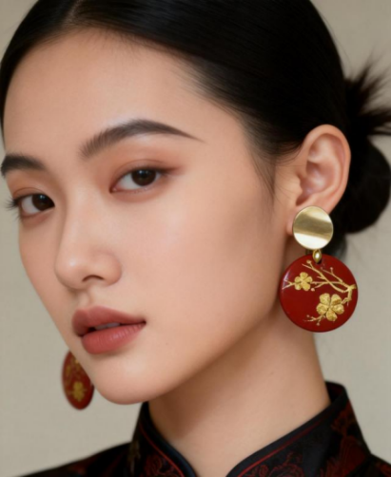

Figure 4.1January plum blossom pattern lacquer art earrings-with restrained color palette to abstract reinterpretation of floral patterns.
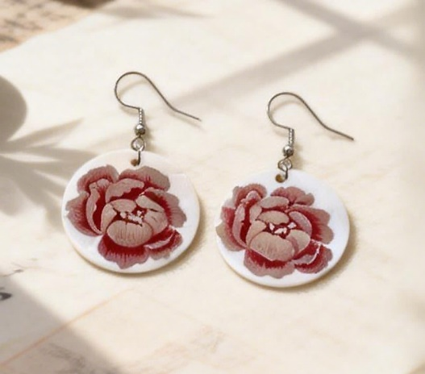

Figure 4.2 April Peony Pattern Lacquer Ears: Circular Ring Structure and Multi-layer Lacquer Surface Effect.
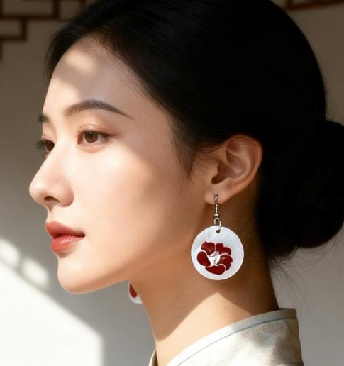

Figure 4.3 Illustration of the Detail of Camellia Flower Earrings in November- Lacquer Layer Superposition and Flower Pattern Integration Technique.

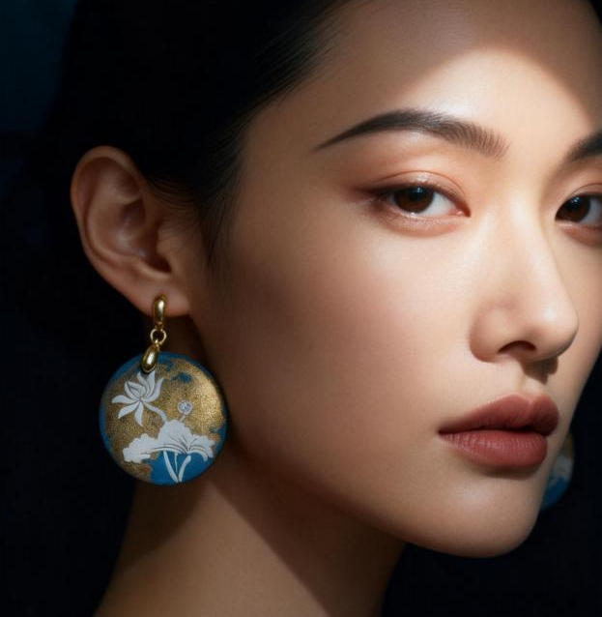

Figure 4.4 Side View of Lotus Theme Earrings in June-Displaying Size
Proportion and Wearing Effect.

Discussion

1. Translating Cultural Meaning Through Design
In relation to Research Objective 1, the findings indicate that the symbolic meanings embedded within the twelve lunar flowers constitute a coherent cultural semantic system that can be systematically analyzed and translated into contemporary design language. Through the examination of cultural texts, visual motifs, and symbolic structures, the study clarifies how each lunar flower embodies specific moral values, temporal attributes, and aesthetic principles within traditional culture.
The design outcomes demonstrate that cultural symbolism can be preserved without literal replication. Strategies of selective abstraction and symbolic recoding enable continuity while allowing space for contemporary interpretation. By retaining core semantic values such as purity, resilience, prosperity, and cyclical temporality the lacquer ear ornaments maintain cultural integrity while achieving visual clarity and modern relevance. These findings confirm that cultural meaning can be effectively sustained through design translation rather than direct imitation.
During the process of symbolic transformation, particular attention was given to balancing tradition and modernity. For instance, plum blossom motifs were reinterpreted through linear branch structures and serrated patterns; lotus contours were simplified into curved geometries; and the complex layering of chrysanthemum petals was distilled into repetitive geometric units. This process eliminated excessive detail while enhancing formal legibility and rhythmic harmony in alignment with contemporary aesthetic expectations. Such an approach demands advanced compositional sensitivity, as designers must simplify form without compromising symbolic recognizability.

2. Morphological Transformation and Design Strategies
Addressing Research Objective 2, the study confirms that traditional floral imagery can be successfully transformed into contemporary lacquer ear ornaments suitable for young and middle-aged consumers aged 25–45. Design strategies—including geometric simplification, circular structuring, proportional control, and the deliberate use of negative space—proved critical in adapting complex traditional patterns into wearable forms.
The transformation process illustrates that contemporary wearability requires a careful equilibrium between cultural expression and functional consideration. By prioritizing visual rhythm, structural stability, and aesthetic restraint, the designs achieve compatibility with modern fashion contexts without diminishing symbolic meaning. Morphological transformation therefore operates as a mediating mechanism between cultural tradition and contemporary user expectations, enabling traditional motifs to re-enter everyday life.
At the strategic level, the study proposes a structured method of abstract recoding. Extraction serves as the foundational step, identifying the essential visual elements of lunar floral motifs. Deconstruction functions as the pivotal stage in modernizing traditional patterns, requiring a departure from naturalistic compositions through geometric reduction or minimalist reinterpretation. Reconstruction then integrates these transformed elements creatively with lacquer materiality to generate a new design language. The inherent qualities of lacquer such as stratification, luminosity, and textural variation provide rich possibilities for the contemporary reinterpretation of lunar floral imagery.

3．Materiality, Temporality, and Wearability
With regard to Research Objective 3, the findings emphasize the dual significance of lacquer as both a material and a conceptual medium. The layered application process, surface depth, and temporal characteristics of lacquer contribute to the expression of time, craftsmanship, and cultural continuity. Conceptually, the material properties of lacquer align with the cyclical temporality embedded in lunar culture, thereby reinforcing the symbolic dimension of the design outcomes.
Furthermore, wearability analysis confirms that lacquer ear ornaments can effectively function as everyday and semi-formal accessories when factors such as weight control, dimensional proportion, and structural balance are carefully managed. Although the evaluation relied primarily on observational analysis and documented wearing scenarios, the results convincingly demonstrate the feasibility of integrating traditional craftsmanship into contemporary wearable design. Taken together, material experimentation and ergonomic considerations validate lacquer ear ornaments as a viable medium for contemporary cultural expression.
From the perspective of emotional design, the study also verifies the applicability of (Norman, 2013) framework within lacquer earrings design. The visceral level generates immediate sensory attraction through lacquer chromatics and floral aesthetics. The behavioral level prioritizes wearing comfort and styling adaptability, supporting both daily integration and the long-term value of cultural heritage. The reflective level engages the symbolic meanings of the twelve lunar cycles, encouraging deeper contemplation of temporal passage and seasonal transformation. Consequently, lacquer ear ornaments evolve beyond decorative objects to become cultural vessels that inspire reflection on traditional heritage, natural cycles, and the broader significance of human experience.

Suggestions
Future research should explore broader applications of lunar floral motifs across diverse design categories and investigate interdisciplinary collaborations involving emerging technologies and sustainable materials. Designers are encouraged to adopt systematic methodologies when engaging with cultural resources to avoid superficial appropriation and to promote meaningful reinterpretation.
Additionally, examining user perception and international reception may enhance the global relevance of culturally grounded design. By positioning heritage as a source of innovation rather than constraint, designers can contribute to the long-term vitality of traditional culture within contemporary creative industries.

References
Guangzhou, L., & Porncharoen, R. (2024). Emotional design of traditional Chinese cultural creative products based on user demand. Journal of Graphic Engineering and Design, 15(2), 39–49. https://doi.org/10.24867/JGED-2024-2-039
Guo, H., Asliza, A., & Chen, P. (2025). Craftsmanship revitalized: Revival path of intangible heritage in modern life and cultural sustainability. Environment-Behaviour Proceedings Journal, 10(31), 275–281. https://doi.org/10.21834/e-bpj.v10i31.6488
Li, M. (2020). Aesthetic paradigm of symbolic abstraction in traditional Chinese ornamentation. Art History Quarterly, 45(1), 50.
Lucas, A., Chapin, M., Lin, M., & Jia, X. (2015). The Chinese soul in contemporary jewelry design. Gems & Gemology, 51(1), 18–30. https://www.gia.edu/gems-gemology/spring-2015-chinese-soul-contemporary-jewelry-design
Norman, D. A. (2013). The design of everyday things: Revised and expanded edition. Basic Books. https://openlibrary.telkomuniversity.ac.id/home/catalog/id/117488/slug/the-design-of-everyday-things-revised-and-expanded-edition.html
Panofsky, E. (1955). Meaning in the visual arts: Papers in and on art history. Doubleday.
Ruan, Y. (2023). Exploring the symbolism and cultural importance of Dunhuang lotus motifs. International Journal of Education and Humanities, 10(3), 22–24. https://doi.org/10.54097/ijeh.v10i3.11785
Subedi, A., & Hamal, S. (2023). The impact of different flowers on human psychology: A comprehensive review. Malaysian Mental Health Journal, 2(2), 36–38. https://doi.org/10.26480/mmhj.02.2023.36.38
Xiao, Y.-M., Shen, J.-S., & Lin, C.-L. (2024). Exploring on the extraction of attributes of lacquer art fashion products. Creative Education, 15(4), 617–642. https://doi.org/10.4236/ce.2024.154038
Yijing, C., & Sharudin, S. A. (2023). The integration of traditional symbols and modern product design: Cultural inheritance and innovation. Global Journal of Emerging Science, Engineering & Technology, 1(1), 19–25. https://doi.org/10.56225/gjeset.v1i1.17
Ying, W. (2018). A national flower’s symbolic value during the Tang and Song dynasties in China. Space and Culture, 21(1), 46–59. https://doi.org/10.1177/1206331217749765
Zhang, L. (2019). The symbolic attributes and semantic depth of Chinese floral patterns. Journal of Visual Culture, 12(3), 123.
Zhao, Q., & Sahari, F. (2025). Generating the Tang dynasty’s floral medallion motifs using shape grammar for innovative applications. Journal of Lifestyle and SDGs Review, 5(3), e05122. https://doi.org/10.47172/2965-730X.SDGsReview.v5.n03.pe05122

A Comparative Study of Aesthetic Principles

Minimalism and Realism in Contemporary Art

Thammasin Darunk¹
Chulalongkorn University¹
Thammasin.D@chula.ac.th

Abstract
This research presents a comparative analysis of aesthetic principles between Realism and Minimalism, the two pivotal art movements that employ fundamentally contrasting approaches to visual representation. Realism focuses on the meticulous depiction of objective reality and social truths through intricate detail and narrative depth. Minimalism, in contrast, seeks to reduce art to its most fundamental essence, emphasizing geometric form, industrial materials, and the physical presence of the object.

The study investigates the fundamental dichotomy between complexity and simplicity by examining key visual elements including line, color, space, and materiality as the primary aesthetic principles through which the two movements diverge. Through a qualitative methodological framework, the research explores how these movements influence viewer perception: Realism invites the audience into a representational world governed by external references, whereas Minimalism demands an immediate, self-referential encounter with the artwork itself.

The findings reveal that Realism operates on the principle of mimesis and social truth engaging the viewer through narrative absorption, while Minimalism operates on ontological truth directing the viewer toward a phenomenological awareness of space and physical presence. A theoretical framework mapping this aesthetic spectrum from complexity (Realism) through the hybrid zone (contemporary mixed-media) to simplicity (Minimalism) is established, providing aesthetic indicators applicable to contemporary art education and mixed-media installation practices.

Keywords: Minimalism, Realism, Aesthetic Principles, Complexity, Simplicity, Viewer Perception, Contemporary Art, Mixed-Media

1. Introduction

The history of Western art has long been shaped by the tension between the faithful representation of the visible world and the exploration of pure form and essence. Among the movements that most sharply illustrate this contrast are Realism and Minimalism. While they emerged in different historical moments and responded to different socio-political conditions, they represent two opposing poles of the aesthetic spectrum: the abundance of detail versus the essence of form.

Realism, which gained prominence in the mid-19th century, sought to depict the world as it truly appeared focusing on social truths and the intricacies of human experience. It relies on technical virtuosity, complex composition, and direct reference to external reality. In contrast, Minimalism, arising in the 1960s, challenged the very definition of art by stripping away all non-essential elements. By utilizing industrial materials and geometric forms, Minimalist artists aimed to create self-referential works that emphasize the physical presence of the object and its relationship to the surrounding space.

This divergence raises fundamental questions regarding aesthetic perception and the role of the viewer: How does the meticulous detail of a realistic work alter cognitive engagement compared to the stark presence of a minimalist structure? This research aims to provide a comprehensive comparative analysis of these two movements examining their visual languages, philosophical foundations, and lasting impact on contemporary mixed-media practices.

Research Objective
The primary objective of this research is to establish a theoretical framework that maps the aesthetic spectrum between Realism and Minimalism, identifying the aesthetic indicators derived from the fundamental dichotomy between complexity and simplicity, in order to apply this framework to contemporary mixed-media and installation art practices and art education.

2. Literature Review
2.1 The Philosophy and Evolution of Realism
Realism emerged in the mid-19th century as a reaction against the idealized subjects of Romanticism. According to Nochlin (1971), the essence of Realism lies in its commitment to the depiction of the low, the common, and the contemporary with unflinching precision. Artists such as Gustave Courbet pioneered the movement by insisting that art should only represent things that are visible and tangible. The Realist artist functions as a social witness, documenting the conditions of everyday life through an abundance of descriptive detail. This commitment to external reference and mimesis the faithful imitation of the visible world distinguishes Realism as an art of complexity demanding substantial visual information to construct a believable and recognizable reality (Greenberg, 1961; Foster, 1996).

2.2 Minimalism: The Essence of Form and Objecthood
Minimalism, which flourished in the 1960s, sought to strip art of any metaphorical or narrative meaning. Donald Judd (1965), in his influential essay Specific Objects argued that art should exist as a three-dimensional entity free from the illusions of painterly tradition. Fried (1967), in Art and Objecthood highlighted Minimalism's unique focus on the physical presence of the object in space. Key practitioners including Robert Morris advocated for the "Specific Object" works that are neither painting nor sculpture in the traditional sense, but self-referential entities. The literature on Minimalism emphasizes reductionism and the use of industrial materials (steel, aluminum, fluorescent light) to eliminate the artist's subjective hand, shifting focus to geometric properties and environmental interaction (Battcock, 1995; Meyer, 2001).

2.3 Comparative Aesthetic Principles: Complexity and Simplicity as Perceptual Variables
A crucial area of literature involves the cognitive response to visual stimuli. Research in Empirical Aesthetics establishes that visual complexity as embodied in Realism and visual simplicity as embodied in Minimalism demand fundamentally different modes of perceptual engagement. Berlyne (1971) argued that the hedonic value of an artwork is often linked to its complexity and the arousal it creates in the viewer. High-complexity images tend to stimulate longer engagement and more detailed cognitive processing, whereas high-simplicity works redirect attention from depicted content to the physical experience of space, material, and scale (Colpitt, 1993; Pallasmaa, 2012). This perceptual dichotomy between narrative absorption and phenomenological awareness constitutes the theoretical core of the present study.

Prior comparative studies, such as those by Foster (1996) and Meyer (2001), have examined the philosophical opposition between mimetic and ontological art. However, these studies have not systematically mapped this opposition as a continuous aesthetic spectrum with defined indicators applicable to contemporary mixed-media practice a gap this research addresses.

2.4 Contemporary Art and Mixed-Media as Independent Variables

For the purposes of this research, Contemporary Art and Mixed-Media function as the two key independent variables through which the theoretical framework is defined and applied.

Contemporary Art refers to art produced from approximately the 1970s to the present, characterized by its diversity of media, global perspectives, and engagement with social, cultural, and technological issues (Barrett, 2011). It does not follow a single style or movement, but embraces pluralism, allowing artists to draw simultaneously from multiple traditions, including both Realism and Minimalism. Within contemporary art, the aesthetic principles of both movements are continuously negotiated, hybridized, and subverted.

Mixed-Media Practice is understood as an artistic methodology in which artists deliberately combine materials, techniques, and conceptual frameworks from different traditions within a single artwork. As Sullivan (2010) notes, mixed-media practice enables artists to navigate the spectrum between the complexity of Realism and the reductionism of Minimalism — combining representational imagery with minimalist spatial structures to produce multi-layered aesthetic experiences. These two concepts are therefore not merely contextual; they define the domain within which the aesthetic spectrum of this study is applied and tested (Alberro & Stimson, 1999).

3. Research Methodology
This study employs a qualitative research methodology, utilizing a comparative analysis framework to examine the visual and philosophical divergence between Realism and Minimalism. The research is structured into four phases.

3.1 Data Collection: Primary and Secondary Sources
Primary sources include original artworks from both traditions analyzed directly through visual and phenomenological description as well as artists' statements, manifestos, and interview transcripts. Key primary texts include Donald Judd's Specific Objects (1965) and Gustave Courbet's exhibition statements, which document each movement's philosophical intent from the practitioners' perspective.

Secondary sources include art historical scholarship, peer-reviewed journal articles, exhibition catalogs, and theoretical essays. Representative secondary sources include Nochlin's Realism (1971), Fried's Art and Objecthood (1967), Berlyne's Aesthetics and Psychobiology (1971), and Pallasmaa's The Eyes of the Skin (2012). These sources provide the critical and theoretical frameworks through which the selected artworks are interpreted and compared.

3.2 Comparative Formal Analysis

The core of the research involves a systematic comparison of selected case studies — representative works from Realism (e.g., mid-19th-century works by Courbet) and Minimalism (e.g., Donald Judd's stacks, Agnes Martin's grids) — analyzed according to the following criteria:

- Visual Elements: Line, shape, color, and texture
- Compositional Structure: Spatial arrangement, perspective, and narrative depth
- Materiality and Technique: Traditional mimetic techniques versus industrial materials

3.3 Philosophical and Phenomenological Inquiry

To address the objective regarding viewer perception, the research applies phenomenological analysis investigating how the abundance of detail in Realism and the essence of form in Minimalism alter the viewer's perceptual engagement with space and time. This phase bridges the gap between the object's physical properties and the viewer's cognitive experience (Pallasmaa, 2012).

3.4 Thematic Analysis and Framework Synthesis
The collected data are analyzed through content analysis and thematic analysis. Thematic patterns are identified and categorized according to four aesthetic variables consistent throughout the study:

1. Degree of visual complexity versus simplicity (Perception)
2. Mimetic versus ontological function (Representation)
3. Narrative versus phenomenological engagement (Viewer Engagement)
4. Concealed technique versus exposed materiality (Materiality)

These four variables are maintained consistently as the primary analytical categories across all phases of the study. The final phase synthesizes the comparative findings into a Theoretical Framework presented graphically in the Research Results section.

4. Research Results
The comparative analysis of Realism and Minimalism reveals a fundamental divergence in the philosophy of representation, the use of visual elements, and the nature of viewer engagement. The results are organized around the four aesthetic variables established in the methodology.

4.1 Perception: Visual Complexity vs. Simplicity
Realism employs a high degree of visual complexity utilizing tonal gradation, atmospheric perspective, organic line, and rich surface detail to create illusionary depth and descriptive abundance. Minimalism employs visual simplicity (essentialism) using flat color, hard edges, and geometric seriality to emphasize the object's physical boundaries and reduce visual information to its minimum. This fundamental difference in perceptual load constitutes the first and primary axis of the aesthetic spectrum.

4.2 Representation: Mimetic Truth vs. Ontological Truth
Realism operates on the principle of mimesis: the artwork serves as a transparent window to an external reality. Its truth is measured by its fidelity to the social, emotional, and physical world outside the artwork. Minimalism rejects external references in favor of ontological truth: a minimalist object does not represent something else it simply is. While Realism seeks to describe the world, Minimalism seeks to occupy it (Judd, 1965; Fried, 1967).

4.3 Viewer Engagement: Narrative Absorption vs. Phenomenological Awareness
The study identifies a significant shift in the viewer's role across the aesthetic spectrum. In Realism, the viewer is engaged as a spectator reading the depicted scene, following social narratives, and projecting meaning onto represented content (narrative absorption). In Minimalism, the viewer becomes a presence made aware of their own body in relation to the artwork and the surrounding space (phenomenological awareness). Contemporary mixed-media works strategically occupy the space between these two modes, creating a position of critical reflection in which the viewer simultaneously reads and inhabits the work (Tuchman, 1970; Pallasmaa, 2012).

4.4 Materiality: Concealed Technique vs. Exposed Industrial Material
Realism conceals its medium the invisible brushstroke maintains the illusion of reality. Minimalism celebrates its materiality raw industrial materials such as steel, concrete, and fluorescent light draw direct attention to the work's literal physical presence. In contemporary mixed-media practice, materiality becomes hybrid and layered combining representational surfaces with structural industrial elements to create productive tension between the two poles.

4.5 Theoretical Framework: Mapping the Aesthetic Spectrum
The most significant result of this study is the identification of a theoretical framework that maps the aesthetic spectrum from Realism (complexity) to Minimalism (simplicity), with contemporary mixed-media practice positioned in the Hybrid Zone between the two poles as shown in Table 1.

Table 1: Mapping Aesthetic Principles across the Spectrum Realism, Hybrid Zone, and Minimalism
Aesthetic Variable | Realism (Complexity) | Hybrid Zone  (Contemporary Mixed-Media) | Minimalism (Simplicity)
Perception(Visual Complexity) | High: tonal gradation, organic line, atmospheric depth | Selective: strategic juxtaposition of detail  and reduction | Low: flat color, hard edge, geometric seriality
Representation  (Mimetic Function) | External reference artwork represents external reality (Mimesis) | Inter-contextual juxtaposition of real and abstract elements | Self-referential the object is its own subject (Ontological)
Viewer Engagement | Narrative absorption spectator of depicted scene | Concealed technique (invisible brushstroke, illusionistic surface) | Phenomenological awareness bodily presence in space
Materiality | Concealed technique (invisible brushstroke, illusionistic surface) | Hybrid and layered (mixed-media, combined materials) | Exposed industrial material (steel, concrete, fluorescent light)
The four variables map consistently across the spectrum from left (Realism / Complexity) to right (Minimalism / Simplicity), with the Hybrid Zone representing the position of contemporary mixed-media and installation practices. This framework provides a structured vocabulary for analyzing, producing, and evaluating artworks that navigate between representation and abstraction.
5. Discussion
5.1 The Dialectics of Detail and Essence
The results confirm that Realism and Minimalism represent two distinct philosophies of truth-telling in art. Realism relies on the accumulation of descriptive data to convince the viewer of an external reality; Minimalism relies on subtraction to reveal the literal truth of the object itself. As argued by Nochlin (1971), Realist detail provides a social and historical anchor. In contrast, Minimalist simplicity, as seen in the works of Judd (1965), liberates the object from narrative constraints, enabling a more immediate, non-hierarchical encounter. This dialectic has proven generative for subsequent movements fueling Post-minimalism, Conceptualism, and contemporary installation practice.
5.2 Phenomenological Shift and the Role of Space
A significant finding of this research is the transition from depicted space (Realism) to activated space (Minimalism). In Realism, the viewer looks into a virtual, represented world, often losing awareness of their physical surroundings. In Minimalism, the artwork functions as a catalyst for spatial awareness that the viewer's movement through actual gallery space becomes constitutive of the aesthetic experience. These findings align with Fried's (1967) critique of theatricality, and with Pallasmaa's (2012) sensory theory, which suggests that the fullest aesthetic encounters engage the body as well as the eye.
5.3 Implications for Contemporary Mixed-Media Practice
Contemporary mixed-media artists occupy a privileged position within the aesthetic spectrum. By combining the descriptive power of Realism with the phenomenological directness of Minimalism, they produce works that both represent and present, that both narrate and demand presence. The Theoretical Framework developed in this study particularly Table 1's four-variable mapping, provides a practical vocabulary for this practice and for its critical evaluation. In mixed-media print installation, for example, a realistic printed image can provide narrative or social commentary, while a minimalist installation structure defines the viewer's spatial and bodily engagement.
5.4 Educational Significance
The framework also carries significant implications for art education. Teaching students to consciously move between the poles of the aesthetic spectrum from descriptive representation to radical reduction encourages a more versatile and philosophically grounded approach to making. Students who understand the four aesthetic variables of the spectrum can make more intentional decisions about perception, representation, engagement, and material in their own practice.
6. Suggestions
6.1 Practical Recommendations for Artistic Practice
Artists working in contemporary mixed-media should explore the Hybrid Zone of the aesthetic spectrum by strategically juxtaposing realistic details within minimalist structures. Specific strategies include:
- Placing highly detailed realistic elements within geometric, reduced compositions to create productive tension
- Using industrial materials (characteristic of Minimalism) as surfaces for realistic imagery
- Designing installations that guide the viewer between narrative absorption and phenomenological awareness through spatial sequencing
6.2 Recommendations for Art Education
Art curricula should present the spectrum between Realism and Minimalism not as a binary opposition but as a continuous field for exploration. Educators should:
- Design assignments requiring students to translate a realistic observation into a minimalist form, and vice versa
- Use Table 1's four-variable framework as a pedagogical tool for analyzing and evaluating artworks
- Introduce mixed-media projects in which students consciously position their work along the aesthetic spectrum and articulate their choices using the framework's vocabulary
6.3 Suggestions for Future Research
1. Future studies could investigate how digital minimalism and hyper-realism in virtual reality environments influence perception, and whether the four aesthetic variables identified in this framework apply to immersive digital media.
2. Empirical studies using eye-tracking or EEG technology could provide measurable data on the perceptual differences between high-complexity (Realist) and high-simplicity (Minimalist) artworks, validating the phenomenological claims of this research quantitatively.
3. Cross-cultural comparative studies could examine how the aesthetic values of complexity and simplicity manifest differently in non-Western traditions such as Japanese Wabi-sabi or Chinese Literati painting broadening the framework's applicability beyond its Western art-historical foundation.
References
Alberro, A., & Stimson, B. (Eds.). (1999). Conceptual art: A critical anthology. MIT Press.
Barrett, T. (2011). Criticizing art: Understanding the contemporary (5th ed.). McGraw-Hill.
Battcock, G. (Ed.). (1995). Minimalism: A critical anthology. University of California Press.
Berlyne, D. E. (1971). Aesthetics and psychobiology. Appleton-Century-Crofts.
Colpitt, F. (1993). Minimal art: The critical perspective. University of Washington Press.
Foster, H. (1996). The return of the real: The avant-garde at the end of the century. MIT Press.
Fried, M. (1967). Art and objecthood. Artforum, 5(10), 12–23.
Greenberg, C. (1961). Art and culture: Critical essays. Beacon Press.
Judd, D. (1965). Specific objects. Arts Yearbook, 8, 74–82.
Meyer, J. (2001). Minimalism: Art and polemics in the sixties. Yale University Press.
Nochlin, L. (1971). Realism. Penguin Books.
Pallasmaa, J. (2012). The eyes of the skin: Architecture and the senses (3rd ed.). John Wiley & Sons.
Sullivan, G. (2010). Art practice as research: Inquiry in visual arts (2nd ed.). SAGE Publications.
Tuchman, P. (1970). Minimalism and the viewer. Art Analysis Journal, 2(1), 15–28.

